JS007
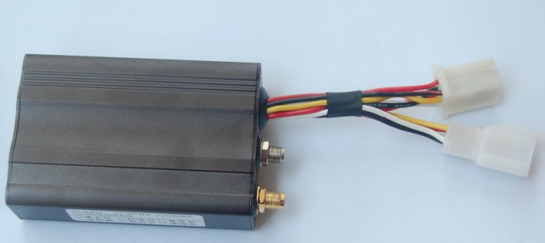
Index
1. Product Profile 3
2. Technician parameter 5
3. T007 Packing list 6
3.1. Standard Accessories 6
3.2. Optional accessories 6
3.3. Packing View and Serial setting cable 7
4. T007 Indicator light description 8
5. Functions Description 9
5.1. GPRS Mode Function 9
5.1.1. Real-time positioning 9
5.1.2. Tracking a car 9
5.1.3. Cut Fuel/Recover Fuel 9
5.1.4. Alarm functions 9
5.1.5. Remote Control functions 11
5.1.6. Mileage statistics 11
5.2. SMS Mode Function (Command list in appendix 1) 12
5.2.1. Real-time position 12
5.2.2. Tracking function 12
5.2.3. Cut Fuel/Recover Fuel 12
5.2.4. Alarm functions 12
5.2.5. Remote Control Functions 12
6. Device Installation 13
6.1. Prepare works 13
6.2. Setting steps 13
6.3. Install in a car 15
6.3.1. Prepare for install 15
6.3.2. Device diagram 15
6.3.3. Main Device Installing 15
7. Extended function 18
8. FAQ 19
Appendix1. SMS Command List 20

Product Profile
Thank you for choosing our company's T007 GPS tracking products, please carefully read the instructions before operating.
T007 satellite positioning system combined with positioning, monitor and observe, alarm for help, advertising, vehicle scheduling, image capture and tracking functions, it’s easy to use, easy to operate, the characteristics of a full-featured, the main applies to vehicles and other mobile object location and tracking services.
T007 fully supports the GPRS network data transmission function, GPRS platform can be combined with software to make it more widely used in large-scale cluster monitoring, emergency scheduling, location-based services, traffic safety management and many other fields.
Product Features:
- Support GPS positioning mode.
- Support GPRS network data transmission.
- Support for multi-directional terminal parameter settings.
- Support for automatic sleep, standby operating current is only 100mA.
- Support for peer-to-peer monitoring, point to group control, group all-round monitoring of the group.
- Combined with anti-theft, positioning, monitoring control, alarm, such as first aid and tracking multiple functions with a full range of integrated products.
【Note】
- Herein after referred to as the 【default user】refers to has been set and saved to the product of all numbers communications devices.
- This product is SMS / GPRS dual-communication version of the product factory default SMS mode, GPRS mode For more information, please refer to the instructions on the relevant SMS communication mode conversion instructions convert.
- If an error or a write command to send messages of non-default number of instructions, this product will ignore it.
- All input commands can be upper and lowercase letters in English, but need to use standard English punctuation, , must not use other input method instead of the English punctuation. And all SMS commands is no space character between the contents.
- This product is factory default password is 【1234】, convenience-oriented brochures to explain the following command operation for some of those involved in your password are the product's default password 【1234】
- This product is not waterproof, choose the dry location to install, and pay attention to water moisture.
- Please installed and use this product properly

Technician parameter
Name | Parameter
Gift Box Dimension | 77x53x23 mm
Color | Black
Working voltage | 9V -- 30V DC
Working current | 80 mA – 110 mA（12V/DC）
Back-up battery life time | Up to 1 hour
Tracker size | 85mm X 55mm X 29mm
Weight | Tracker weight | 0.2kg | Total packet | 0.5kg
Working temperature | -25℃ -- 65℃
Moisture | 5% -- 95%（Non-water vapor condensation state）
GSM Frequency | 900MHz/1800MHz or 850MHz/900MHz/1800MHz/1900 MHz
GPS Module | Latest U-BLOX locating module from Sweden or Skylab
GPS Sensitivity | -159Db
GPS Frequency | 1575.42 MHz
Receiving panel structure | GPS module 32-channel
Locating accuracy | < 5m （95％）
Cold start time | < 45s(in average）
Heat start time | < 2 s (in average）
LED indicator light | usage of green / red dual-color LED indicator light shows the GPS / GSM status
GSM Chipset | HUAWEI or SIMCOM

JS007 Packing list

Standard Accessories
Accessory | QTY | Image | Function
Packing | 1PCS | 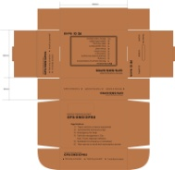 | Gift box packing
Main device | 1PCS |  | main device
GSM Antenna | 1PCS | 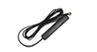 | Receiving GSM network signal
GPS Antenna | 1PCS | 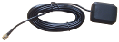 | Receiving satellite locating signal data
Relay | 1PCS |  | Implementation of the core components of cut off and restoration of circuits/circuit of the relevant action command
MIC | 1PCS |  | User to monitor the voice inside the vehicle, to assist users to determine more accurate
6PINcable | 1PCS |  | Product and vehicle or other equipments installing cable connecting with the main wire（SOS button included）.
Binding cables | 3PCS | / | For fixing the main device and wire used
Double stickers | 2PCS | / | For fixing the main device and wire used

Optional accessories
Name | QTY | Image | Function
Bus Camera(optional ) | 1PC |  | Photographing in vehicles
Taxi camera(optional) | 1PC |  | Photographing in vehicles

Packing View and Serial setting cable
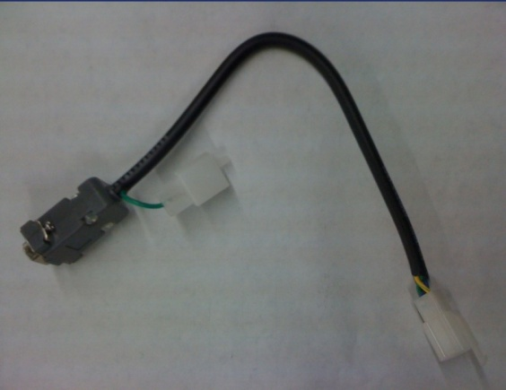
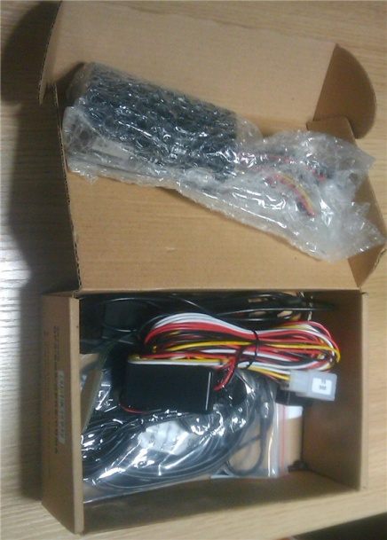

JS007 Indicator light description
LED light | Light on | Light off | Description
Green | 5 seconds | 1 second | GPS located
Green | 1 second | 1second | GPS unlocated
Green | 0.5Second | 0.5Second | Initialization
Red | 1 second | 1second | Searching for GSM network
Red | 0.5S | 3S | GSM network normal
Red | Flashing quickly |  | transferring /receive GPRS data
 | Light off |  | Device power failed or LED indicator light error
Red | Light always on |  | In call or dialing

Functions Description

GPRS Mode Function

Real-time positioning
Monitoring center can directly locate the specified vehicle terminal call view, in-car terminal will immediately return to the central monitoring platform details such as vehicle location data. Location information mainly include: time, longitude, latitude, speed, location, location signs, vehicles and terminal status.

Tracking a car
Monitoring center can specify the device GPS data transmission time interval, then device can upload data automatically with that interval. Factory default upload interval is 30 seconds, adjustable range is 5-65535 seconds; if interval is set to "" 5 seconds ", the terminal device will automatically return to the "5 seconds".

Cut Fuel/Recover Fuel
Monitoring center can be personalized to the designated vehicle and a remote disconnect the circuit or to restore the circuit, when the vehicle terminal receives instruction on cut/restore fuel to take down/ restart car movements.

Alarm functions

Emergency alarm
When there is an emergency or ask for help, press 2 seconds on emergency button, triggering an emergency alarm, the terminal immediately upload emergency alarm. Control center received alarm information could confirm and cancel alarm. (Installation please refer to the installation section【101A6B) instructions】.
If the terminal is currently in standby sleep mode, wake-up immediately to activate and exit standby mode, will also alarm to the Control center.

Over speed alarm
Traffic speed alarm refers to the device in accordance with the speed to allow the user to set the value of constantly monitoring the vehicle speed, when the vehicle speed exceeds preset allowable value, the device will send over speed alarm data reported to the Center, when the speed dropped to the default values that the abolition of alarm. Center received alarm data may confirm or cancel the alarm. Driving speed alarm set value in the 0-255 (km/h) range.

Geo-fence alarm
Exit into the Geo-fence alarm refers to the user to set up and one or more permitted to enter or exit out of the region ban, issued and saved to the device, device according to the user to set the value of the constant monitoring of vehicle movement position, when the vehicle latitude and longitude value exceeds a user preset value, that is reported the corresponding data to enter or exit alarms, when the vehicles return to the user default settings will be canceled within the police. Users can confirm or cancel the alarm on demand. Electronic fence delineated the largest number of 25, delineation of the size limitation.

Device main power loss alarm
When the vehicle power supply was cut off the terminal will issued a power off warning in 3 seconds, at the same time start the backup battery power supply (can last around 30min), again automatically detect whether the alarm is canceled after 30 seconds, Center received alarm information could confirm and cancel alarm. If the terminal is currently in standby sleep mode, will wake-up immediately to activate and exit standby mode, will also alarm to the center.

The fatigue driving alarm
Overtime drive; also known as fatigue, driving is mainly a continuous monitoring of driver fatigue, driving out to bring the traffic safety problems. When the alarm function to open overtime driving, driving conditions to determine the state of ACC in the ON state duration beyond the default values, ie central issue, when the ACC began to open the device time, when the preset value is exceeded, the device will be immediately sent to the Center of fatigue driving alert data, the user can confirm or cancel the alarm on demand.

Illegal ignition warning
Illegal fire alarm is set on condition the driver are not allowed to start engine within the restrict time. The device will report data on illegal fire alarm. Determine the conditions for this function is mainly "user to set the start / end date and time, ACC status from OFF to ON" .
Functional implementations: Users can set the open platform software illegally firing the starting date and end date, from start / end time. When the vehicle starts vehicle within a preset time, this device will immediately uploaded to the center platform of illegal fire alarm information. Center received the information after temporary abolition of the alarm, can also cancel the alarm.

Custom Defined Alarm
The device with 2-way custom test line (the test line of the definition and installation please refer to the section described in the installation of the 【101A2B installation instructions】) in order to meet specific customer needs. When the user needs to customize sensor alarm function can be defined according to their own needs the name of the line alarm. As defined by the test line before it is triggered, the device will immediately send a custom alarm to the central data center can be confirmed after the receipt of alarm information and cancel alarm.

Remote Control functions

Remote monitoring
Monitoring center communication platform can be set as monitor callback number, send "listen in" command; the terminal will automatically call-back telephone eavesdropping operation. (Requires SIM card enable call function)

Remote modify Control centre parameters
Device parameters can be changed by GPRS according to user needs, include server IP/port and APN (Access Point Name). After the device is set to change to new IP /port and APN, device will restart and parameters effective immediately.

Remote restart terminal equipment
Abnormal when an individual terminals on-line or for other reasons need to restart the device, the user can correspond to the terminal through the platform to restart the instruction issued.

Remote check the version and device status
In order to facilitate the timely after-sales and technical personnel to follow up and follow-up technical upgrades, etc., the terminal device with terminal software version of the remote query feature. Users also can check the device status remotely; include device parameters, device GSM/GPS status, ACC status, and so on.

Mileage statistics
The beginning of this equipment from loading automatically calculate mileage, and mileage statistics from time to time to report to center platform, the center can take advice on car mileage table stored data; also the centers can clear the vehicle mileage data stored by platform, or be derived in accordance with set time-related mileage statistics. The mileage statistics value no bigger than 16000 km.

SMS Mode Function (Command list in appendix 1)

Real-time position
Device user can use authorized cell phone number send TRACK ONCE command content to device, and device will reply real-time attitude and longitude to user’s cell phone immediately.
【Note】: SMS have much longer delay time than GPRS, and may have different delay time in different mobile networks. Please find detail command in appendix 1

Tracking function
User can set a time interval to device for data uploading, after that, device will send position data to the primary authorized number.
【Note】: The SMS tracking time interval unit is minute, the minimum interval is 1 minute. Device will send longitude and latitude to home number (primary authorized number) with set interval. Please find detail command in appendix 1

Cut Fuel/Recover Fuel
Users can send cut/recover Fuel text command to device to stop/recover a car. Please find detail command in appendix 1

Alarm functions
- SOS Alarm
- Over Speed Alarm
- Device Main Power Loss Alarm
- Customer Defined Alarm

Remote Control Functions
- Remote Monitoring
- Remote Modify Communicate Parameters
- Remote Restart Device
- Remote Check Device Status

Device Installation
After you get JST007 product, please familiar with it and test it before you install it in a Car, please check the packing list and make sure the packing and product quality well.

Prepare works
- Amwell GPS product
- Serial setting cable and TEsetting software
- Local GPRS SIM card
- 12V DC power supplier
- Computer with COM port (if do not have COM port, can use USB to serial cable instead)

Setting steps
Step1. Insert SIM card into the Amwell GPS device.
Step2. Connect the antennas (GSM antenna and GPS antenna) to device
Step3. Connect the power cable to 12V DC power supplier (according to the diagram of device connection in 3.0)
Step4.Connect the device with your computer via serial setting cable (or via serial cable and USB to serial cable)
Step5.Start program TEsetting
Step5.1. Select communicate type and set communicate port.
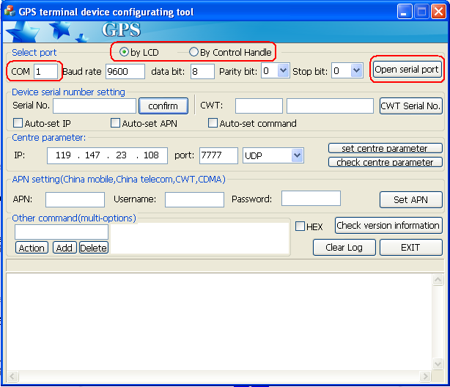
1.Select communicate type：269 by LCD, 103 by control Handle
2.Communicate port, select port in use
3. Click to open the port
Step5.2.Check communicate
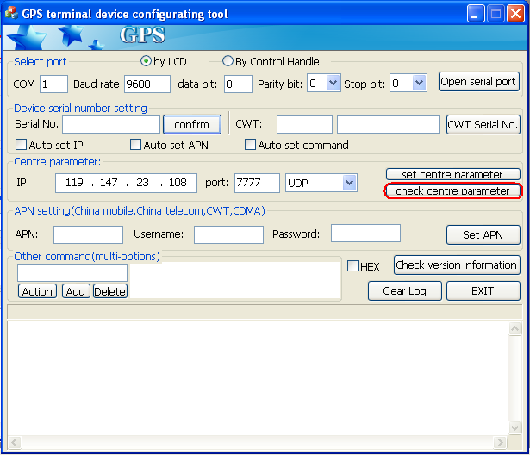
3. Click to check if the serial communicate is ok
Step5.3. Set center parameter and APN
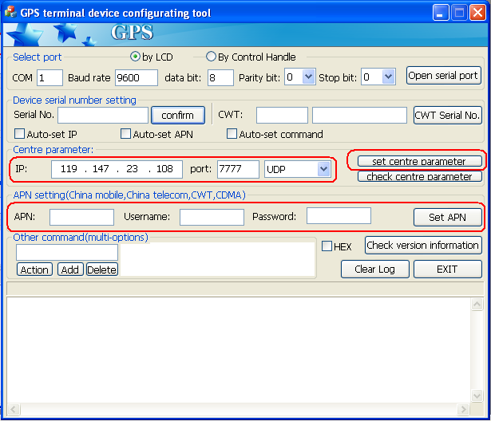

Install in a car

Prepare for install
This device using in 12V, 24V motor vehicles, will not conflict with the original car system, in order to facilitate fault diagnosis and unusual dispute after installation, please check the pre-installation inspection and truthfully inform the owner.
- Check all function whether it is normal for the vehicle. Such as: lights, small lights, turn lights, fog lights, ACC, CD drive, electric windows, remote control cars in the original control, engine start, engine run and so on.
- Check various decorative items inside the vehicle whether standards to connect, and check if decoration of the car has damaged.
- Check with the product, if is damaged, if there is exposed copper phenomenon.

Device diagram
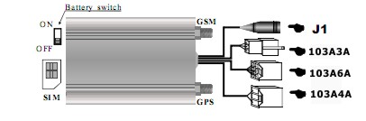

Main Device Installing

SIM card installing instruction
- Please set up SIM card service password before installing it into the device.
- JST007 implementation of the various functions required to support the SIM card SMS message, GPRS functionality (Internet CMNET business), make sure that the SIM card with the functions (if required monitoring, call features, SIM card is also required to support voice calls function ).
- Installation or removal of SIM card, please do that under power off the device completely, otherwise it is possible the SIM car burnt.
- SIM card installation or removal required for "+" screwdriver inserted back-end of equipment, forced inside the top hole until the SIM card connectors automatically exit the host. Specific installation steps please refer to the following diagrams:
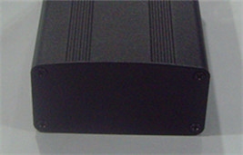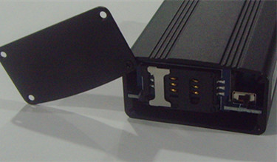

103A6A Cable Installation Diagram
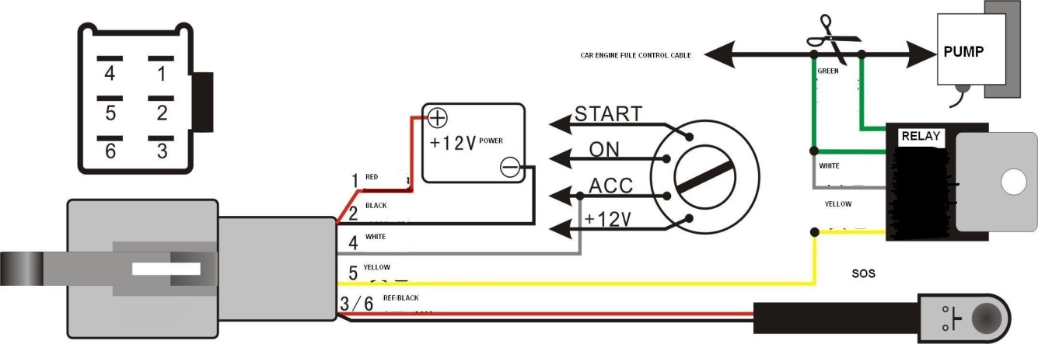
Power positive wire (red):
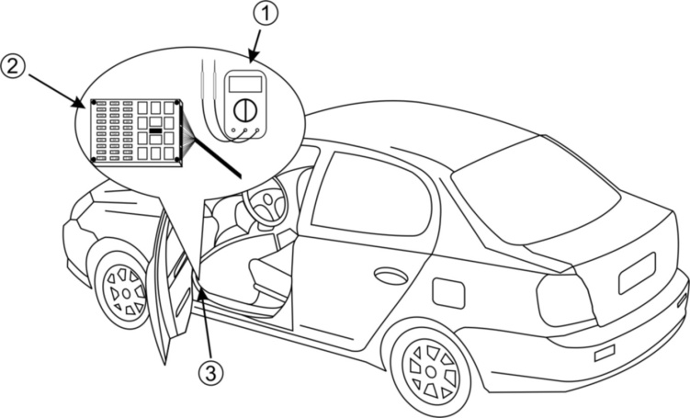
power positive installation in general with the battery positive, or with the fuse box’s total power input regular wire (+12 V). During installation process must choose thick (+12 V) wires. And bind up the joint.
Power negative electrode (black):
The vehicle body metal itself is a negative electrode; usually the installers will choose a screw and loosen it, and then tied to negative electrode wire, tightening it. However, it will be oxidized after longtime, so it will cause bad effect to the device.
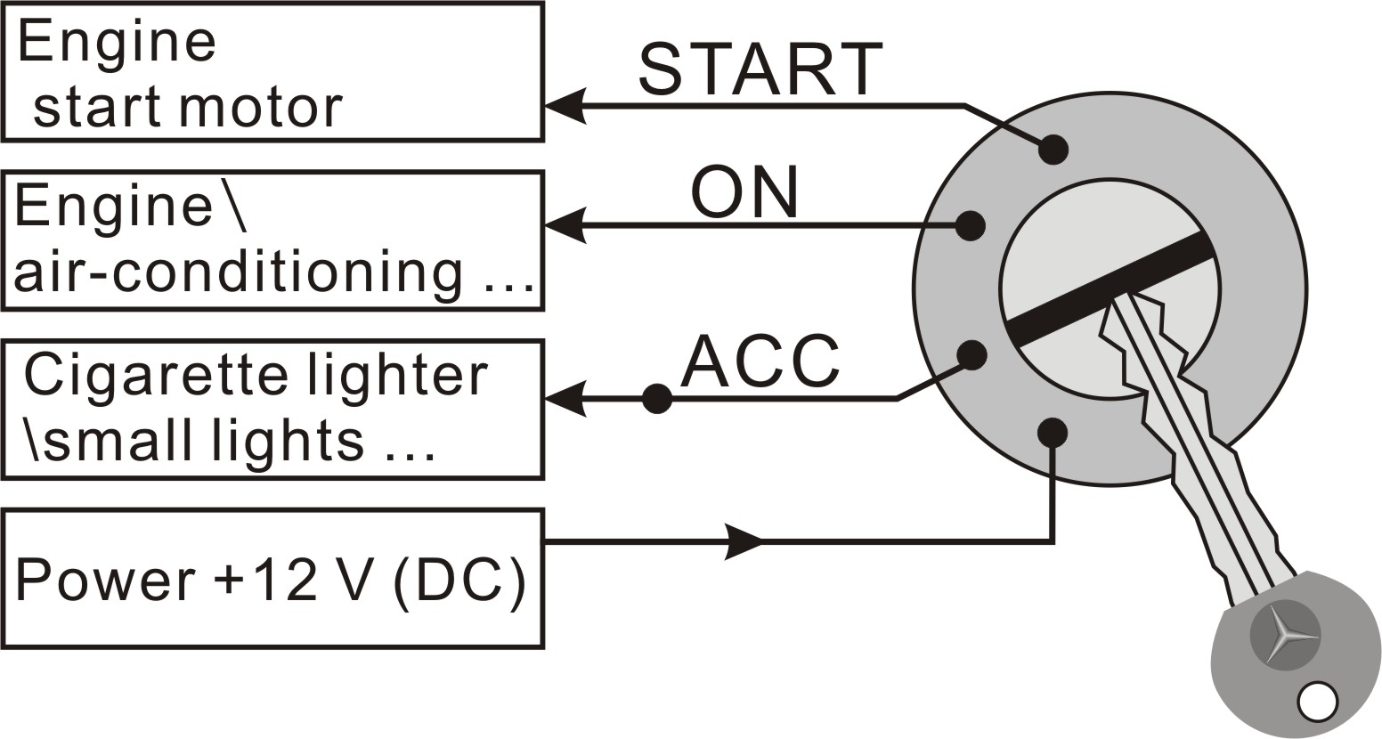
Most of the vehicles need one or more screws to the anti-oxidation process, adopted with multi-point grounding after gather up all cathode-ray by parallel way, to ensure the grounding. So we should adopt the second way for grounding. (Remarks: Its theory is the same as (+12) electricity cable, better to be thick.
ACC detecting wire (white):
This wire is majorly for detecting the ACC signal. Please refer to the illustration for the ACC signal in the vehicle key insert part.

Electricity Power cut wire control (yellow):
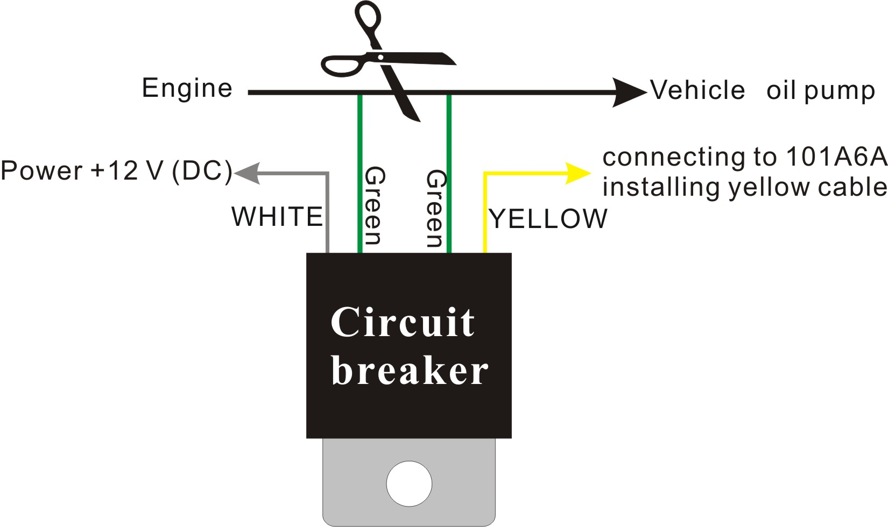

JST007 of the power control wire (yellow) is mainly used to meet with the power relay circuit to cut off the motor fuel or engine circuit, forced to stop the engine running.

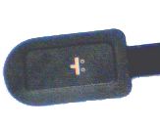
Emergency button:
Basically use for the driver while face an emergency situation, can trigger the button JST007 equipment to issued a distress call to the center information platform. Usually trigger button does not easily found location.

103A4A Installation Instructions (optional)
Lines are installed 103A4A main camera cable connector; detailed installation and use please refer to the "camera installation instructions" and "platform operating instructions" related to the contents of the operation.

GPS/GSM Antenna installing Guide
The location of device is recommended to install in the following locations and require ensuring the right way, at the same time, please pay attention to the concealment.
- In front bumper or near the headlight.
- Between the rear case of the engine and windshield glass.
- Before the bottom of the windshield and dashboard, GPS antenna should face to the sky. (Note: Dashboard with many metal supporting places, so please put it in the upper place, and avoid vehicle cables and speak or air condition where with strong magnetic，distance with 20CM
- The back seat of the cab below the rear windshield.
【Note】
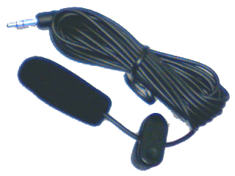
During the installation process, please ensure GPS antenna head to being on a horizontal plane , and without metal material covered.

Monitor Microphone (J1)
Please pay attention to the monitor MIC, make sure it is far away from magnetic fields, such as: sound box speakers, power cord, usually installed on the cab roof near the top.
【Note】: This function must support SIM card with voice function

Extended function
Photo taking function:
- The camera is infrared camera. It will automatically start the infrared function while in the dark enviorenment.
- The camera also works even using the backup battery while the main power is off.
- The resolution of the photo is: 240x320 or 480x640. The size is from 10K-20K.
- We could send photo-taking command through the monitoring software in GPRS mode. Also it support be triggered by the SOS button or by other triggers.(like door trigger or other self-defined trigger). You can enable or disable the trigger function. Defaulted: closed. For more details, please go to check the camera's user manual.
Note: Camera is optional devices.

FAQ
NO | Problem | Reason | Solution
1 | Light off after device connected with power | Power installed incorrectly | 1. power of positive and negative reversed installed  2. the power of the cathode not connected;  3. the original car is controlled by main power switch (mostly in 24V vehicle.)
1 | Light off after device connected with power | Power disconnection | 1. The electricity installing cable is power off  2. fuse disconnect  3. Main device and the connector to installing lines bad connected
1 | Light off after device connected with power | Indicator light fail | Bad quality for the indicator light
2 | Power indicator light flashing quickly or long time light on. | SIM card could not be detected after electricity power on, and the device reset repeatedly. | 1. Did not put in SIM card  2. SIM card inserted into the wrong direction  3. SIM card failure.
3 | Equipment are often not positioned | GPS antenna fail | 1. The installation of GPS antenna location is incorrect,  2. GPS antenna quality problem, please change another one.  3. GPS antenna and main device connecting point is loosen or wrong place  4. GPS antenna head attacked by water or damp
3 | Equipment are often not positioned | Signal interference | The electromagnetic interference Speaker  the market part of the electronic dog, wireless MP3 signal interference  explosion-proof film covered to stopped GPS signal
4 | Sending SMS to SIM card inside the device, but no response | Don’t reply messages | Command format error  punctuation errors  no money in SIM card balance
4 | Sending SMS to SIM card inside the device, but no response | Occasionally don’t reply messages | Bad signal  Installation position wrong signal shielding serious
5 | There is noises when listen in | Installation problems | Please avoid magnetic field installing power supply
6 | No alarm when device power off | Back-up battery failed to open | Find a local dealer to open backup battery switch
7 | Unable to power on the vehicle | Installation or operation function improperly adjust | - Due to operation mistake to cut the fuel pump.  - relay failed or the installation wires damaged and short-cut body.

Appendix1. SMS Command List
NO |  | IUSSE |  |  | SEND COMMAND |  | ANSWER COMMAND |  | REMARK
1 |  | SET SERVER IP AND PORT |  |  | AS1234IPPO:119.147.23.108;7777；# |  | IPPO:119.147.23.108;7777,26339788;OK |  | Response content is “IP””Port””Current Device ID”
2 |  | SET TERMINAL ID |  |  | AS1234IDDO:26339788# |  | IDDO:26339788;OK |  | Response Current Device “ID”
3 |  | APN | Access Point Name |  | AS1234APN:CMNET# |  | APN:CMNET;OK |  | At most 39 Character
4 |  | APN | APN user name |  | AS1234USER:USER# |  | USER:USER;OK |  | At most 39 Character
5 |  | APN | APN password |  | AS1234GPRSPASS:GPRS# |  | GPRSPASS:GPRS;OK |  | At most 39 Character
6 |  | Restart Device |  |  | AS1234RSGS# |  | GSM/restart; OK |  | Device Restart
7 |  | Factory Reset |  |  | ASAX*%UPAS# |  | PASSWORD:1234;OK |  | All the parameters will be reset to factory set except IP、Port、Device ID and APN
8 |  | Device Status Enquiry |  |  | AS1234STATE# |  | ID:99999999 VER:V1.05 IP:119.147.23.108,7777 CEN: AUT: CSQ:19 GPS:OK ACC:ON GPRS:30 POWER:ON NETTYPE:SMS |  | - ID：Current Device ID  - Ver.：Current firmware version  - IP：Current IP and Port  - CSQ：Current GSM signal strength  - GPS：GPS available or not  - ACC：Current ACC status  - GPRS：Current GPRS data upload interval  - POWER：Current Power mode  - NETTYPE：Current Communicate mode
9 |  | Awake up Device |  |  | AS1234SLEEP:# |  | SLEEP:OFF |  | Temp leave sleep mode, will sleep again after 25min
10 |  | Open/Close Standby Mode |  |  | AS1234WAKEUP:5＃ |  | WAKEUP:5 |  | - Unit：“hour”；  - Type and range：“0” Close；1~18:sleep for this time and wakeup for 25minutes.
Standard function
1 | Communicate Mode Set |  |  | AS1234SMGP:0＃  AS1234SMGP:1＃  AS1234SMGP:2＃ |  | SMGP:UDP;OK  SMGP:TCP;OK  SMGP:SMS;OK |  | 1、“0”UDP Mode；  2、“1”TCP Mode；  3.、“2”SMS Mode
2 | Home Number Set |  |  | AS1234HOME:13510642316＃  AS1234HOME:0＃ |  | HOME:13510642316;OK  HOME:CLEAR;OK
3 | Authorized Number2 Set |  |  | AS1234EMPOWER:13590251897#  AS1234EMPOWER:0# |  | EMPOWER:13590251897;OK  EMPOWER: CLEAR;OK
4 | Change Device Password |  |  | AS1234PASSWORD:5678# |  | PASSWORD:5678;OK
5 | Track Once |  |  | AS1234WHERE# |  | TRACK:Latitude:+22.123456;Longtitude:+113.123456;speed:98;ACC:ON |  | Send once
6 | SET TRACK Interval  (send to Control Center only) |  |  | AS1234TRACK:3#  AS1234TRACK:0# |  | Track:3;OK  Track:OFF;OK  Data upload format ：  TRACK:Latitude:+22.123456;Longtitude:+113.123456;speed:98;ACC:ON |  | 1、Unit：“Minutes”  2、type：“0” cancel ；
7 | Cut Fuel |  |  | AS1234ENGINE:OFF# |  | ENGINE:OFF;OK
8 | Recover Fuel |  |  | AS1234ENGINE:ON# |  | ENGINE:ON;OK
9 | Monitoring Number |  |  | AS1234LISTEN:13481944860# |  |  |  | Device will phone to telephone nuber13481944860
10 | SET Speed Limit |  |  | AS1234SPEED:120#  AS1234SPEED:0# |  | ESPE:120;OK  ESPE:OFF;OK |  | 1、Unit：“km/h”  2、Type and range：“0”cancel speed limit
11 | User Defined Alarm 1 |  |  | AS1234 DEFINED1:1#  AS1234 DEFINED1:0# |  | User-defined1:ON;OK  User-defined 1:OFF;OK |  | Value type：“0”forbid；“1”open  (The alarm information will only send to authorized Number and center number when Device work in SMS mode )
12 | User Defined Alarm 2 |  |  | AS1234 DEFINED2:1#  AS1234 DEFINED2:0# |  | User-defined2:ON;OK  User-defined 2:OFF;OK |  | Value type：“0”forbid；“1”open  (The alarm information will only send to authorized Number and center number when Device work in SMS mode )
13 | SOS Alarm |  |  | SOS Button Pressed |  | SOS:Latitude:+22.61916;Longtitude:+113.85543;speed:52;ACC:ON |  | 1. 1.Device will alarm once when SOS button pressed for 3s, device will send sos alarm once to home number and authorized number set.  2.Detail alarm content see【Note 2】
14 | Main Power loss Alarm |  |  | Main power supply cut (backup battery must open) |  | POWER: Latitude:+22.60227;Longtitude:+113.86878;speed:44;ACC:OFF |  | 1. Device end sos alarm once to home number and authorized number set.  2. Detail alarm content see【Note 2】
Note：In all the SMS commands , the delete method of all the settable parameters is to change the parameters to ‘0’，it will be recognized as invalid command if leave it blank。
Note 1：
SMS Command format:
AS 1234 APN : CMNET ＃
Start chars Password Type Content End Char
Note 2
TRACK: Latitude:+22.59429; Longitude:+113.86971; speed:0; ACC:ON
Type Current latitude Current longitude Current speed Current ACC status

