Magnet vehicle GPS Tracker
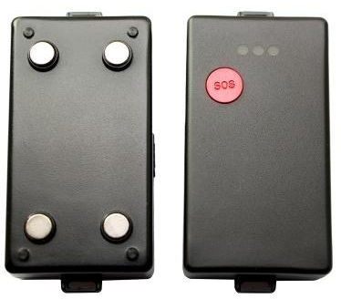

USERS MANUAL
V6.4

Updated on 2013/01/08
1 Product Overview
This Tracker provides peace of mind by showing you with your mobile phone or PC the location of your targets via SMS or GPRS.
TRACKER has the following features
- Tracking via SMS or GPRS
- Built in 2600Mah battery which can work for more then 20days .
- Waterproof IP56
- Magnet tracker . no need wire connection , easy to use
- Current location report
- Tracking by time interval
- SOS alert
- Geo-fencing control
- Low battery alert
- Speeding alert
- Removable and rechargeable internal battery
- Alert when Track enter/exits GPS blind area
- G-SENSOR supported
sleeping mode: when the geo-fence alert and over speed alert is closed , the sleeping mode is active. When the geo-fence or orver-speed alert is enabled , the sleeping mode is closed and gps is keeping on .
2 For Your Safety
Read these simple guidelines. Not following them may be dangerous or illegal. Read the full user manual for more information.
Switch on safely- Do not switch on Track when wireless phone use is prohibited or when it may cause interference or danger.
Switch off in Hospitals– Follow any restrictions. Switch Track off near medical equipment.
Switch off in Aircraft – Follow any restrictions. Wireless devices can cause interference in aircraft.
Switch off when refueling– Do not use Track when at a refueling point. Do not use near fuels or chemicals.
Water Resistance –Track is not water resistant. Keep it dry. Use waterproof bag if necessary.

3 Track Parameters& Panel Description
Item | Specification
Charging Voltage | DC 5V/500mA (Micro USB port)
Internal Battery | Rechargeable and removable 2600 mAh battery (3.7V)
Operating temperature | -20° to 55° C
Humidity | 5% to 95% Non-condensing
GSM module | GSM 900/1800/1900Mhz
GPS Chipset | latest GPS (AGPS)
GPS Sensitivity | -158Db
GPS Frequency | L1, 1575.42 MHz
C/A Code | 1.023 MHz chip rate
Channels | 20 channel all-in-view tracking
Position Accuracy | 10 meters, 2D RMS
Velocity Accuracy | 0.1 m/s
Time Accuracy | 1 us synchronized to GPS time
Default datum | WGS-84
Reacquisition | 0.1 sec., average
Hot start | 1 sec., average
Warm start | 38 sec., average
Cold start | 42 sec., average
Altitude Limit | 18,000 meters (60,000 feet) max.
Velocity Limit | 515 meters/second (1000 knots) max.
Acceleration Limit | Less than 4g
Jerk Limit | 20 m/sec
Work time | 60 hours in sleep mode and 10 hours in normal mode
LED | 3 LED indicators showing power, GPS, GSM status and other operation status.

Panel Description
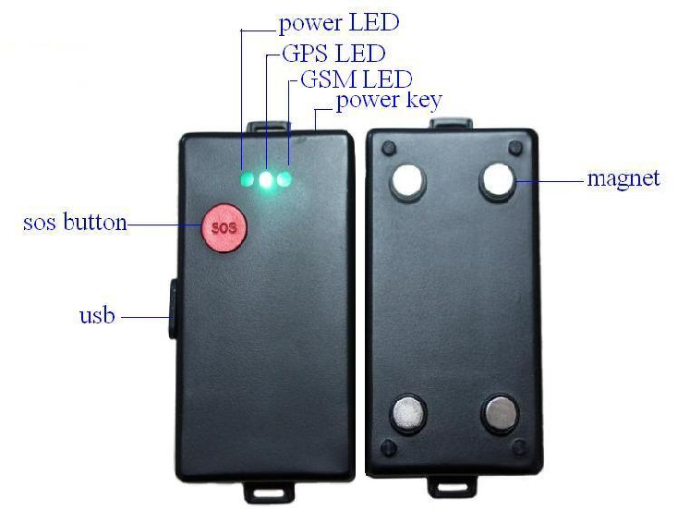
4 Getting Started
4.1 Hardware and Accessories
- USB Power Cable
- User Manual
- Other document or software if required
4.2 Light and Button Functionality
TRACK has four buttons and three LED lights with three different colors to indicate the status of the unit. All LED is enabled when power on, and short click SOS key to change GSM & GPS LED enable / disable status.
3 led are flashing from left to right | The Sim card is not inserted or SIM card is not in normal
Red LED | Indicating power status
Off | Power is off / charging is complete/in sleeping mode
On | charging
Flashing(on for 0.01sec and off for 4.99 sec) | Low power
Flashing (on for 1 sec and off for 4 sec) | Tracker is out of sleeping mode
Green LED-indicating GPS status
Off |  | Device is not ready
flashing in 0.05 seconds and 4.95 seconds off |  | GPS fixed
Flashing(on for 1 second and off for 4 seconds) |  | GPS no fix / GPS power off
Blue LED-indicating GSM status
On |  | One call is coming in / one call is being made
Flashing (on for 0.05 second and off for 4.95 seconds) |  | TRACK is connected to GSM network
Flashing (on for 1 second and off for 4 seconds) |  | TRACK is not connected to the GSM network
Power Button |  | To turn on/off
SOS Button |  | Long press SOS button to send an alarm to location center and make a phone call and/or send an SMS to the preset phone number.  Short press SOS button to change GSM & GPS LED enable / disable status.
1 Button |  | Long press 1 button to make a phone call and/or send an SMS to the preset phone number.
2 Button |  | Long press 2 button to make a phone call and/or send an SMS to the preset phone number.
3 Button |  | Long press 3 button to make a phone call and/or send an SMS to the preset phone number.
4.3 First Use
Ensure that Track has a working SIM installed
- Check that the SIM has not run out of credit
- Check that the SIM Lock code is turned off
Use some other mobile phone to confirm that the PIN code Can not been set ,and that it can dial out and receive telephone calls, and that it can connect to internet by GPRS.
- Charge the battery for at least 3 hours in power-off status using the wall charger or car charger. Red light is on during charging and is off when charging is complete.
4.4 Operation Instructions
- Power On/Off 
- Power On: 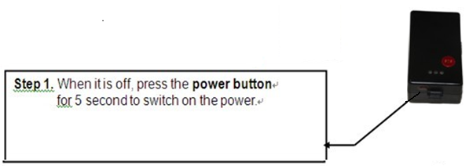

- 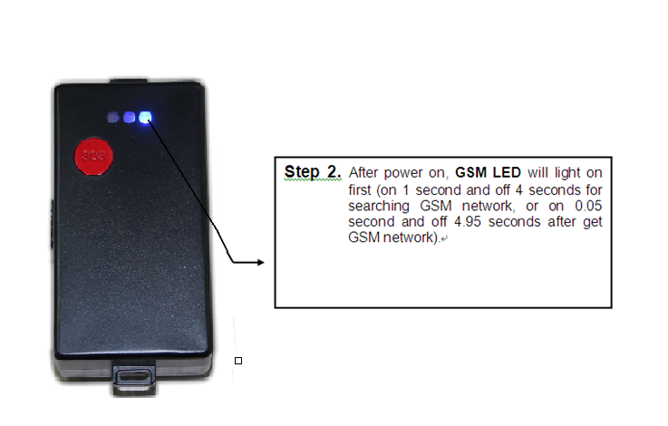
- 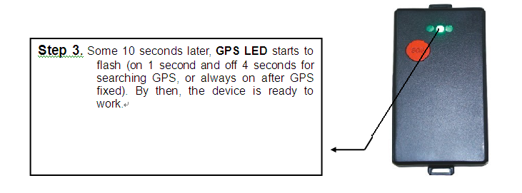

- Power Off:
When it is on, press the power button for 3 seconds to switch off the power; Power/GPS/GSM LED will shut off right now. By then, the device is turned off.
- SOS Emergency Help Function 
When SOS button is long pressed, Track will send alarm to location center, and send a SMS message and make phone call for emergency help. The phone number can be set by the users.
5 SMS command
The device only reply to command with valid password . It will neglect the command iwth invalid pasword. Factory setting password is 000000。
6 GPRS Settings by SMS
Tracking via GPRS, you should set APN for Track
Ensure that your SIM card in Track supports GPRS connection prior to setting.
7 set APN
Command: W<password>,011,APN,APN Name,APN Password,APN DNS,APN Second DNS
Note: If no APN name, APN password, APN DNS and APN Second DNS required, input APN only.
Example: W000000,011,CMNET
TRACK will reply with an SMS (like ‘W01,011, Set device APN OK’) to confirm this setting.
（FOR example ：‘W01,011, Set device APN OK’）。
8 SMS command list
note: ****** is password，factory setting password: 000000.
Description | Command | Remarks
Get current location | W******,000 | Get current location of tracker
Change user’s password | W******,001,###### | ****** is old password  ###### is new password  max 6 characters.
Set interval for automatic timed report | W******,002,XXX | XXX is the interval in minute. If  XXX=000 it will stop tracking
Set preset phone number for SOS button | W******,003,F,P,T | F=0, to turn off this fuction;  F=1, only sending SMS;  F=2, only calling preset phone number;  F=3, both SMS and calling (default)  P=1, set a authorized number for SOS  button  T: Preset phone number. Max. 16 digits
Set over speed alert  When tracker speeds higher  than the preset value, it will  send one over speed alert to  the SOS preset number. | W******,005,XX | XX (the preset value of speed)  =00 , to turn off this function  =[01, 20] (unit: 10Km/h)  For example, W000000,005,08, it will  sent alert when it is over 80Km/h
Set Geo-fence alert  When tracker moves out of  preset scope, it will send one  Geo-fence SMS to the SOS  preset number. | W******,006,XX | XX ( preset distance to original place )  =00, to turn off this function  =01, 30m  =02, 50m  =03, 100m  =04, 200m  =05, 300m  =06, 500m  =07, 1000m  =08, 2000m
Extend Settings | W******,008,ABCDEFG | A=0, turn off the function of sending an  SMS location report to the authorized  phone number when it makes a call to tracker.  A=1, turn on the function of sending an  SMS location report to the authorized  phone number when it makes a call to tracker.  B=0, Google address  B=1, location data complies with NMEA 0183 GPRMC protocol.  For example:  $GPRMC,072414.000,V,3114.3763,N,  12131.3255,E,0.00,0.00,050805,*00  C=0, turn off the function to automatically hang up an incoming call.  C=1, turn on the function to automatically hang up an incoming call  after 4 - 5 rings.  D=0, Turn off the function of sending an SMS when tracker is turned on.  D=1, Turn on the function of sending an SMS to SOS number when tracker is turned on.  E=0, reserved  E=1, tracker shuts down automatically  when the power voltage lower than 3V.  F=0, Turn off the alert when tracker  enters GPS blind area.  F=1, Turn on the alert when tracker  enters GPS blind area. SMS is to be  sent to SOS number  G=0, 3 LED lights work normally  G=1, 3 LED lights stop flashing when  tracker working.  (default value is: ABCDEFG=0100100 )

Presetting by SMS for GPRS tracking (Ensure that your SIM card supports GPRS connection prior to setting)
Set ID for tracker | W******,010,ID |  |  | Tracker ID must not over 14 digits.
Set APN | W******,011,APN,APN Name,APN Password,APN DNS,APN Second DNS |  |  | If no APN name and password  required, just insert APN only;  APN defaulted as ‘CMNET’;  APN + APN name + APN password + APN DNS + APN Second DNS not over 39 characters.
Set IP Address and Port | W******,012,IP, Port |  |  | IP: xxx.xxx.xxx.xxx  Port: [1,65534]
Enable GPRS Tracking  Function | W******,013,X |  |  | X=0, turn off GPRS tracking (default);  X=1, enable TCP
Set Time Interval for  Sending GPRS Packet | W******,014,XXXXX |  |  | XXXXX should be in five digitals and in unit of 10 seconds.  XXXXX=00000, to turn off this  function;  XXXXX=00001~65535, time interval for sending GPRS packet and in unit of 10 seconds.
For more information regarding GPRS settings please refer to <GPRS Communication Protocol>
Set time zone difference |  | W******,032,T | T=0, to turn off this function  T=[-720, 720] to set time difference in  minute to GMT. Default value is GMT  For those ahead of GMT, just input the time difference in minute directly. For example, W000000,032,120  ‘-‘is required for those behind GMT. For example, W000000,032,-120.
Set character for SOS alert message |  | W******,033,P,Char | P is the button number. P=1,  P=1, SOS button  Char is the character in SOS message and max 32 characters
AGPS |  | W******,043,IP,port,sms_num | it can be set by SMS command .  set AGPS SUPL server by SMS
Restore factory setting |  | W******,048 | restore factory setting
Got location in Google link |  | W******,100 | Get location through google link http://maps.google.com/maps?f=q&hl=en&q=55.751,37.616&ie=UTF8&z=16&iwloc=addr&om=1 , click directly the link to log into google map to view the location .
Got location in detailed address |  | W******,052 | Get current location in detailed address
Get version and serial  number |  | W******,600 | To get version and serial number of  current firmware
Set up defencese |  | SF | after setting successfully , once the car is moved or vibrated . the alarm will be sent to authorized number .
Cancel defences |  | CF | after setting successfully , the anti-defences is canceled.
position in coordinates |  | DWJW | send command "DWJW" to tracker . tracker will reply with position data but only to the authorized SOS number .
Get IMEI |  | W******,601 | To get IMEI

9 Tracking on Map
Download Google Earth from http://earth.google.com/
Start the google earth
(For more in formation about Google Earth please refer to http://earth.google.com/) as the following picture shows:
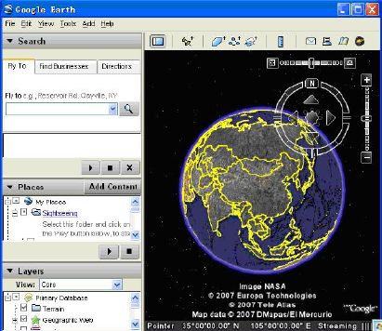

Input the latitude and longitude that you receive from the tracker by SMS and click the search button
Google Earth will display the location for you.
Example:
When you receive:
Latitude=22 32 40.05N
Longitude=114 04 57.74E
Type as the following picture shows:
(Note: you should input the latitude and longitude as:22 32.4005N,114 04.5774E)

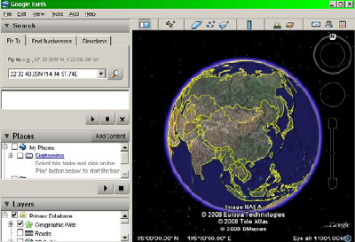

Now you can find the location of your tracker:
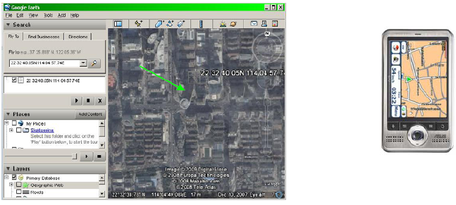
Or you can start the Internet Explorer and connect to http://maps.google.com for displaying the location.
Or you can use local map software on PDA or car navigation device to input the coordinates.
10 Troubleshooting
Problem:Unit will not turn on
Possible Cause: | Resolution:
The power button is not pressed long enough | Press and hole the button for 3-5seconds
Battery needs charging | Recharge battery for 3 hours
Problem:Unit will not reply with SMS
Possible Cause: | Resolution:
Green LED is flashing(on for 1 second and off for 2 seconds) | Make Tracker connected to GSM network
GSM Network is slow | Wait for SMS.Some GSM networds slow down during peak time or when they have equipment problems.
Unit id sleeping | Cancel sleeping mode
Wrong password in your SMS or wrong SMS format | Write correct password or SMS format
The SIM in Tracker has run out of credit | Replace or top up the SIM card
Problem:Green LED is Flashing(on for 1 second and off for 2 seconds)
Possible Carse: | Resolution:
No GSM signal | Check with a mobile phone to see if there is a signal in the area or try to call the unit to see if you hear a ring tone.
NO SIM card | Insert a working SIM card.Check in phone that the SIM can send SMS message.
SIM card ha expired | Check in phone that the SIM can send SMS message.Replace SIM card if needed.
SIM has PIN code set | Remove PIN code by inseting SIM in you phone and deleting the code
SIM is warped or damaged | Inspect SIM,clean the contacts.If re-inserting does not help try another to see if it will work.
Roaming not enabled | If you are in a different country your SIM account must have roaming enabled.
Battery is low | Recharge the unit and the GSM will start working
Problem:Blue LED is Flashing (on for 1 second and off for 2 seconds)or the SMS received strats with ‘Last…’
Possible Cause: | Resolution:
Unit does not have clear view of the sky | Move the unit to a location where the sky is visible.Tall buildings,trees,heavy rain,can cause problems with the GPS reception.
Bad GPS reception | Place the front side of Tracker towards sky
Battery is low | Recharge the unit and the GPS will start working

Message return format: W**,###
###: Prompt number
**: Error Hint
00: Get OK
01: Setting OK
02: Setting Fail
03: Message format Error
04: Password Error
05: Prompt Number Error
06: Modify Password Error
07: Parameter data Error
08: No GPS data
09: Not Support Protocol
10: Over Speed
11: Beyond the Field
12: Invalid GPS data
13: Open Port Error
14: Over time
15: Refuse
16: Get GPS Error
17: Momery arrange Error
18: Auto Alert
19: GPRS OK

