Mini gps vehicle tracker
User manue

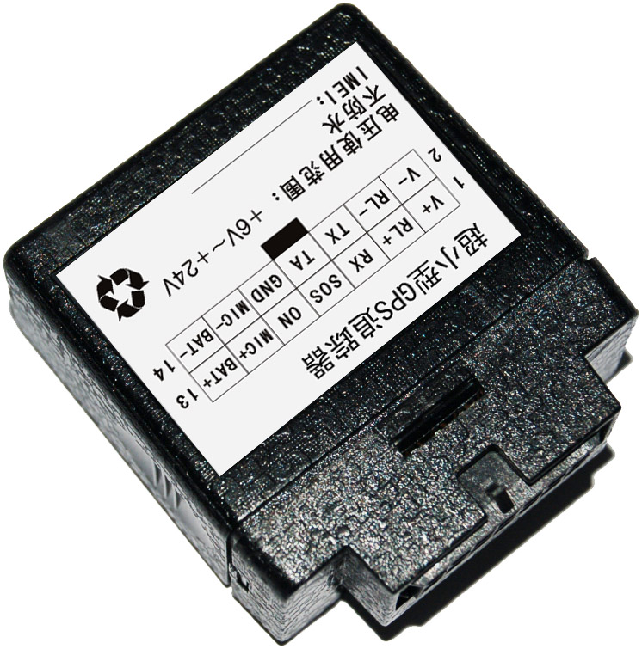

contents

Chapter I Preface 3
I. General 3
II. Notices 3
Chapter II About the Device 3
I. quick guider for device 3
II. Product Features 3
III. Product Specifications 4
Chapter III Use Preparation 4
I.set command by SMS 4
II. to view location by GPRS between server and tracker 5
Chapter 1111 other function guidness 6
1. feedback way by 11
11. engin cut and electricity cut 11
chapterIV
1 command list

Chapter 2 device introduction

一、 quick guide of device
1、 definition of external cable connected
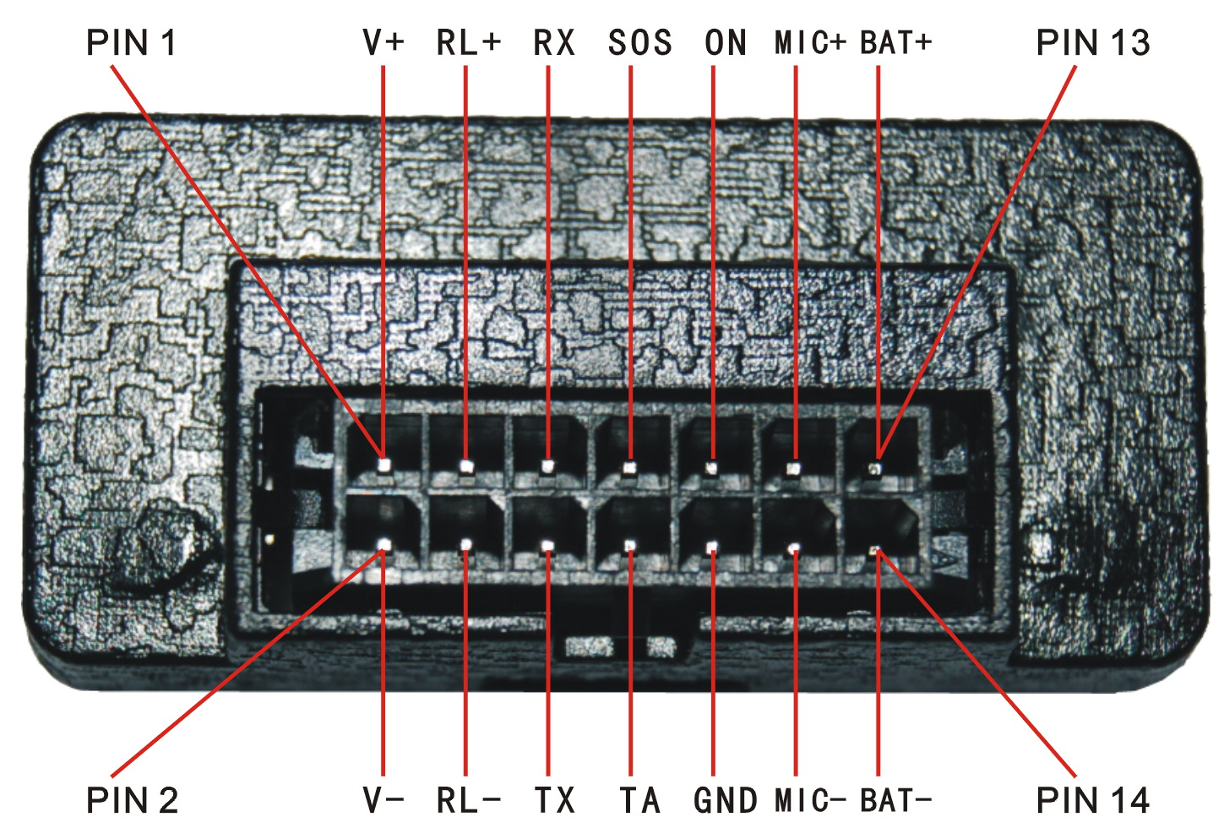
2、Install SIM
Open case and insert SIM as following ：

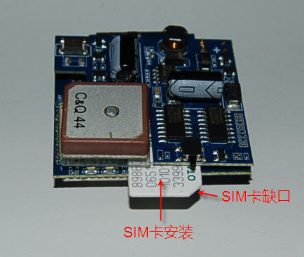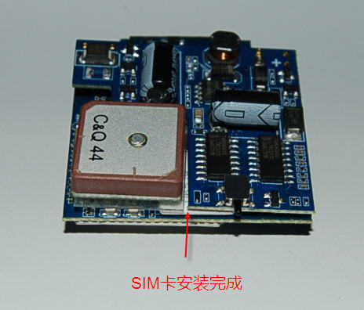
- After insert SIM， pls close the case and connect cable to turn on device。
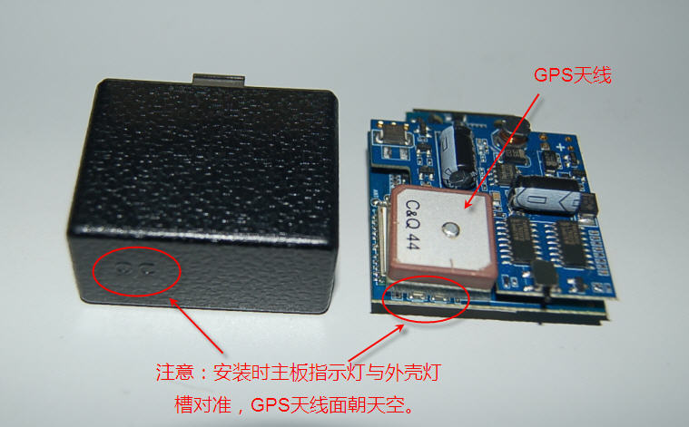
Note：pls follow up the above picture to install each function according to requestment. If just need the basis tracking function, just connect vehicle power to make it be working .
Optional Accessories : relay cutting off electricity ，SOS key and MIC

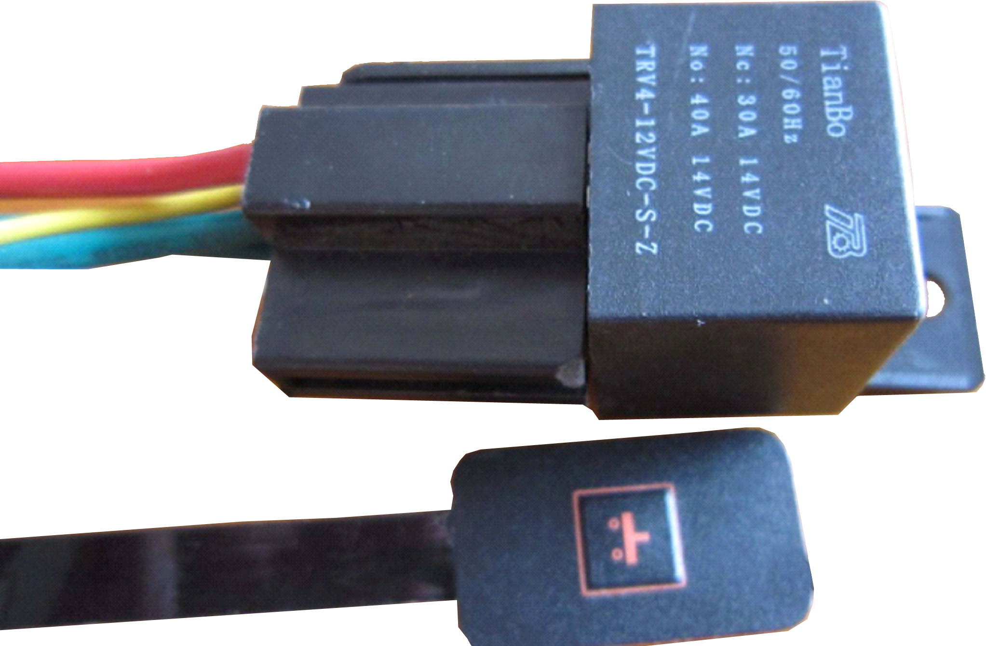

二、device features:

●Regular support continuous tracking control function

●Supporting SMS and Internet inquires the location information

●Supports remote monitoring function

●Support SOS alarm function

●Support ACC condition monitoring

●Supports remote fault oil power function

●Support electronic fence (a/the boundary) alarm

●Support terminal low battery alarm

三、device specification
3.1 technical specification
GSM modul | GSM850/900//18000/1900MHz
GPS sensitivity | -159dBm
GPScenter frequency | L1, 1575.42MHz
GPStracking accuracy | 5-25m
Velocity Accuracy | 0.1m/second
Time Accuracy | Same with GPS
Memory data | WGS-84
Hot start | 1second
Cold start | 38second
Altitude Limit | 18000m
Maxim speed | 515m/second
Weight | ﹤4g

3.2 others
Work temperate | -20---65℃
Humidity | 5%---95%
size（mm） | 50*45*21
voltage | 12V—24V
Average sleeping current | Less then 80MA
LED | power，working
external Alarm on/off key | SOS

Chapter 3 tracking introduction
：
Vehicle tracker is a multi-tracking device integrating voice conversation , SMS and GPS tracking . the following are the instruction of SMS and GPRS tracking way .

一. how to track by SMS ：
a．Send SMS command“666+ user password”to the device，the device would return back coordinatesbySMS.
b. Send SMS command“987+user password”to device，device would return link , to click the link ,the monitor could check the location including part map .
c. send SMS command “988+user password”to device，device would return location of device（to use this function , pls be sure your SIM card is with GPRS opened）
for example ：send “6660000”, the returned data format is as following ：
Lat：latitude direction（N/S） latitude value（ accuracy is last 5 number）
Long：:longtitude direction （E/W） longtitude value(accuracy is last 5 numbers）
Speed： KM/H（accuracy is last 5 numbers)
Direction：（accuracy is last 5 numbers）
Date： YYYY-MM-DD
Time： HH：MM：SS BS： basic information .
FIX: tracking status （A/V）
ID：IMEI
STATE: information status
Valid data example：
Lat:N22.6189
Long:E113.6333
Speed：0.17KM/H
Direction：62.58
Date：2008-06-17
Time：09:39:45
BS：27970eb3
FIX:：A
ID：123456789000001
STATE:SMS

To view location on google map (click to working mode)
To open IE, Input http://maps.google.com, to connect to GOOGLE map web , and then input latitude and longtitude on left corner .
For example：22.544N,113.9107E

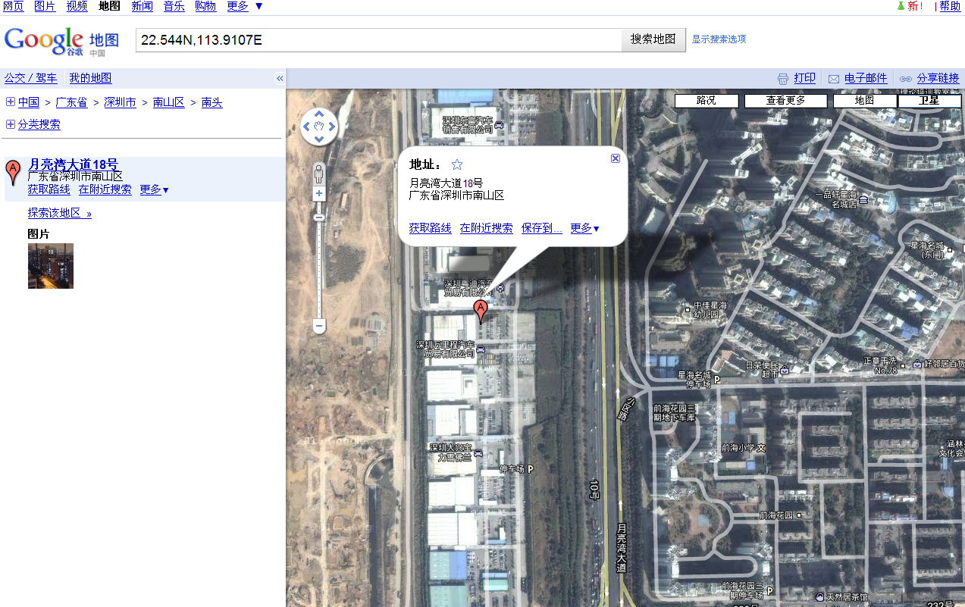
The “A” showing location of device on map 。

Chapter 4 other function operation

一．电话控制的回传方式:
When one of the bind tel number is coming to device , after 2-5 vibration of device , the device would send back coordinates(latitude and longtitude ) .（ pls be sure the SIM used in the device is with function of incoming call display）

二． Function of Engine cut and electronic cut off

Pls refer to instructions of relay

a．send SMS command“223+password”to device，device would send back “RF3 OFF”。 Mean function of engine cut and electronic cut are active。

b. send SMS command “233+password”to device，device would send back “RF3 OK”。 Mean function of engine cut and electronic cut are closed 。

note ：pls be careful to active this function to avoid accident。

Chapter 5、command list
70X+password，X means each working mode | instruction：user could change working mode by this command：if set X as 0，the device transfer data by SMS; if set X as 3，the device transfer data by GPRS。
#710# center tel number# user password## | instruction: the command of center numbers set is to make sure the device could work in normal on conditions of center 。  For example：#710#1066512000#0000##。Center telnumber is set successfully：after , device send “710 CONFIG OK” to mobile phone， if the password is not wrong , device will send out “710 PASSWORD ER”。
#711#tel number1#tel number2#tel number3#password## | Set bind tel number by SMS. If set successfully, the device will send “&711&set successfully&&” by SMS。  For example 1：#711#13800000001#13800000002#13800000003#0000##  Example 2：#711#13800000001###0000##  If set successfully , the device will reply“711 CONFIG OK”，if password is wrong , it will reply“711 PASSWORD ER”。
:#720#alarm mode0-3#password## | Set device alarm mode：  Set 0： no alarm。  Set 1：dial bind number to alarm。  Set 2：Alarm by SMS。  Set 3：Alarm by SMS+ dial bind number。  Instruction ：device will send alarm according to set different command once the back cover is opened or turn on SOS.  For example：#720#3#0000##。After set this command，device is set alarm by SMS+dial bind tel number ， in the same time alarm is sent by SMS, the device dial the first bind tel number。After set successfully , device reply to mobile phone “720 CONFIG OK”， if password is wrong , the device reply“720 PASSWORD ER”。
#730#interval#回传组数#Password## | #730#0#1#0000##，close GPS，cancel gps tracking by interval 。
#803#fixed IP add#port#password## | GPRS set server IP on GPRS mode  Set command of server IP for 988：#988# www.gps02.com#80#password##  This command is to set GPRS center IP 。server IP could be fixed IP value ，format is ： xxx. xxx. xxx. xxx；server IP could be domain，longth should be less then 64 byte。After set successfully，the device sent SMS “&803&set successfully&&”，If the secret code is incorrect, the Message“&803&wrong password&&” will be received 。  For example：#803#119.149.149.114 #30000#0000##  Or set through domain：for example #803# jk.jy100.com#30000#0000##
666+password | Get position including latitude and longtitude
988+password | Get location to show full address
987+pasword | Get position as one link .to click this link is to check the location of device , including part map。
111+password | instruction: after set this command，device will send back basis station data and status information as the following format:：  #basic station information，NO.1 basic station information#status 1 #password 4 characters#pleaed tel number##。  For example ：#25738841,25708e3d,25738709#1#0000#13900139000##
223+password | Open function of engine cut and electronic cut off
233+password | Close function of engine cut and electronic cut off
#770#user new password#user old password## | instruction: after set this command , the user could change password as required。After set successfully, the device will send SMS“770 CONFIG OK”，if the password is wrong, the device will send SMS“770 PASSWORD ER”。  For example：#770#1111#0000##。After set this command，the password is changed from 0000 to be 1111。
#801#letters or number(0-20 character )#password## | Change user name on mode of GPRS  instruction：after set this command，the user name of device is set as requested on the mode of GPRS。 After set successfully , the device will send SMS“801 CONFIG OK”，if wrong password, the device will send SMS“801 PASSWORD ER”。  For example：#801#13900139000#0000##。After set this command ，user name become 3900139000。
#802#APN(letter or number 4-20 character)#login user name(letter or number in 4-20character)#log in password(letter or number in 4-20 character )#password## | Set APN  instruction：after set this command，the APN of the device working on mode of GPRS is set as requested 。after set successfully , the device will send SMS“802 CONFIG OK”，if wrong password, the device will send SMS“802 PASSWORD ER”。  For example 1: #802#CMNET###0000##。After set this command， the APN is CMNET，user name and password are empty。  For example 2:#802#CCDLEN#QIUXIA.21#RX#0000##。After set this command ：APN is CCDLEN，log in user name is ：QIUXIA.21, log in password is RX  Note ：the APN of the device is CMNET before ex-factory.
#751#scope radii（meter）#sample interval取样间隔（minute）#longtitude#latitude#user password ## | Set command of Geo-fence  instruction: after set successfully , the device will send SMS “751 CONFIG OK” to mobile phone，if the password is wrong , it will send SMS “751 PASSWORD ER”。  For example：#751#5000#5#22.5442N#113.91E#0000##  After this command is set , when the tracker moves out of a preset circle scope 5km , it will send an SMS alarm to the authorized phone number for SOS。
# 752#password## | Get Geo-fence data  After set this command successfully , the device will read woking status data and send it back to mobile phone . if the password is wrong , it will send “&752&wrong password&&” by SMS 。  For example：#752#0000##  Return as：#open:1#lat: 22.543685N#lng: 113.910633E#distance:500#time:5#status:2  note：set 1 is to open geo-fence:，set 0 is to close geo-fence alarm。  lat: 22.543685, （N/S）。  lng: 113.910633， （E/W）。  distance:500m， 。  time:5，get time by interval  status:2 the device get valid satellite data , circle scope ,Geo-fence is in working mode。  status:1 active geo-fence, but not get valid satellite data 。  status:0 not set electronic Geo-fence
# 760#password## | stop Geo-fence function  instruction: stop Geo-fence function after set this command。If this command is set successfully , the device will send “760 CONFIG OK” by SMS， if the password is wrong , the device will send “760 PASSWORD ER” by SMS。  For example:#760#0000##
#901## | Get user parameters
#902## | Get GPRS parameters
#904## | Connect GPRS
#905## | Break GPRS
#921## | Active transmission by time  After the command is set, one parameter including internal time counting minutes will be sent to server during GPRS transmission。  After open transmission time counting ：  #EMI number with 15 characters#user name#status#password#data kind#data value#basic station information#latitude,longtitude,speed,direction,#data#time#schedule time in minute##。  note：schedual time in minute is represent by 7 characters。
#922## | Close transmission counting time  After set this command successfully , the device transmit counting time in the normal way  Normal transmission way：  #EMI 15 characters #user name#status#password#data数kind#data value#basic station information #latitude,longtitude,speed,direction#date#time##。
#EMI number(15 characters)#user name#status#password#LPD#data value#bastic station information #latitude,longtitude,speed, direction#date#time## | This command is low voltage Alarm
# EMI number(15 characters)#user name#status#pasword#AUT# data value#bastic station information #latitude,longtitude,speed, direction#date#time## | This command is to return back data information by interval
# EMI number(15 characters)#user name#status#password#SOS# data value#bastic station information #latitude,longtitude,speed, direction#date#time## | SOS alarm function，this information is SOS alarm data
# EMI number(15 characters)#user name#status#password#OUT# data value#bastic station information #latitude,longtitude,speed, direction#date#time## | This information is Geo-fence alarm
Lat：（N/S）  Long：（E/W））  Speed： KM/H  Direction：  Date：YYYY-MM-DD  Time： HH：MM：SS  BS： basic station information  FIX: gps tracking status（A/V）  ID：IMEI  STATE:data state | After send command “666+password”to the device , the device will send back latitude and longtitude by SMS to mobile phone which make incoming call to the device. The incoming call will be hanged off after ringing 2 to 5 tone.。

Notices:
- This device is of non-waterproof design.
- This device must work with the cooperation of GSM/GPRS network.
- Make sure that the SIM card has sufficient balance in order to avoid inconvenience in use.
- This device will not be able to work in case of power-off and out of the service area, even if you are a registered user.
- This device supports the dual positioning mode of GPS and GSM/GPRS.
- Please use this device in a legal area, any illegal consequence will be borne by the user.

