JS1910D+Multi-functional Tracker
User’s Manual



Table of contents
Chapter I Preface 3
I. General 3
II. Notices 3
Chapter II About the Device 3
I. Components 3
II. Product Features 3
III. Product Specifications 4
1. Technical Specifications 4
2. Others 4
Chapter III Use Preparation 4
I. Accessories 4
II. Charge the Battery 5
III. Installation of SIM Card 5
Chapter IV Commands Corresponding to and Operation Method of Basic Functions 6
1. Location Inquiry 6
(1) SMS Inquiry 6
(2) Platform Inquiry 7
2. Setup of Center Number 7
3. Bi-directional Call Function 7
5. Monitoring Function 8
6. Regular Upload Interval Setup 8
7. Function of Changing Password 8
8. Low-Voltage Alarming Function 9
9. Set APN Command 9
10. Electronic Fence Function 9
(1)GPS Fence Function 9
(2)GSM Fence Function 10
(3) Fence Reading Function 10
(4) Function of Canceling Fence 11
11. Auxiliary Functions: 11
Notices: 11

Chapter I Preface

I. General
19D represents the perfect combination of GSM and GPS technologies. This model, with precise dimensions and compact appearance, expresses the advanced workmanship in the GSM and GPS field and is the typical design combing communication products and GPS services.
As a professional security and positioning company, we will provide you with more and better products and services. Before use, please spend several minutes reading this user’s manual in order to understand operation details and obtain better services.

II. Notices
- Please read carefully this user’s manual and always use correct operation methods to prevent any possible errors.
- This user’s manual is for reference only. If some contents and operation steps are inconsistent with those for the actual product, the latter will prevail.
- The defaulted password of this product is 0000.

Chapter II About the Device
19D, as a personal remote positioning device made up of GPS module and GSM/GPRS module, is compact in dimensions and has high accuracy. On the basis of GPS satellites and under dynamic conditions, it can provide you with accurate and correct location information. With such features, it can be used to protect and look for our old people and children. You can use it for safety purpose and other purposes, such as remote positioning to protect property safety and follow animals.

I. Components
1. Inbuilt GPS Module

2. Internet positioning service center, used to receive and send positioning information.

II. Product Features
- GPS individual or fleet positioning;
- GSM /GPRS modem supports two frequency bands, i.e. 900/1800（850/1900）MHz(options)
- High-sensitivity, new workmanship and the most advanced GPS chip;
- Can accurately position even if with weak signals;
- Can work effectively in limited space such as the remote and narrow places in a city;
- Low energy consumption;
- Fast signal capturing;
- Supports single positioning and continuous tracking;
- Supports alarming and remote monitoring;
- Supports fast dial button;
- Supports the location information inquiry by SMS and Internet
- May monitor without disturbing the tracked person and realizes real-time tracking;
- Can position the holder by call or mobile phone SMS;
- In emergency, press the SOS button to have an accurate positioning.

III. Product Specifications

1. Technical Specifications
GSM module | GSM850/1900Hz or GSM900/1800MHz, two combinations
GPS chip | Latest
GPS sensitivity | -159dBm
GPS center frequency | L1, 1575.42MHz
GPS positioning accuracy | 5-25m
GSM positioning accuracy | 100-500m
Speed accuracy | 0.1 m/s
Time accuracy | Synchronous with GPS
Default data | WGS-84
Hot start | 1s
Warm start | 38s
Max. altitude | 18000m
Max. speed | 515m/s
Gravitational acceleration | ﹤4g

2. Others
Working temperature | -20---65℃
Humidity | 5%---95%
Dimensions | 80×49×16 mm
Voltage | Rechargeable 800mAh battery
Power supply | DC5V
Standby time | >48h
Buttons | One SOS emergency button for emergency aid; Call 1, Call 2, Receive and Hang up buttons.

Chapter III Use Preparation

I. Accessories
1. Main unit
2. USB data cable
3. Charger
4. Headset cable (optional)

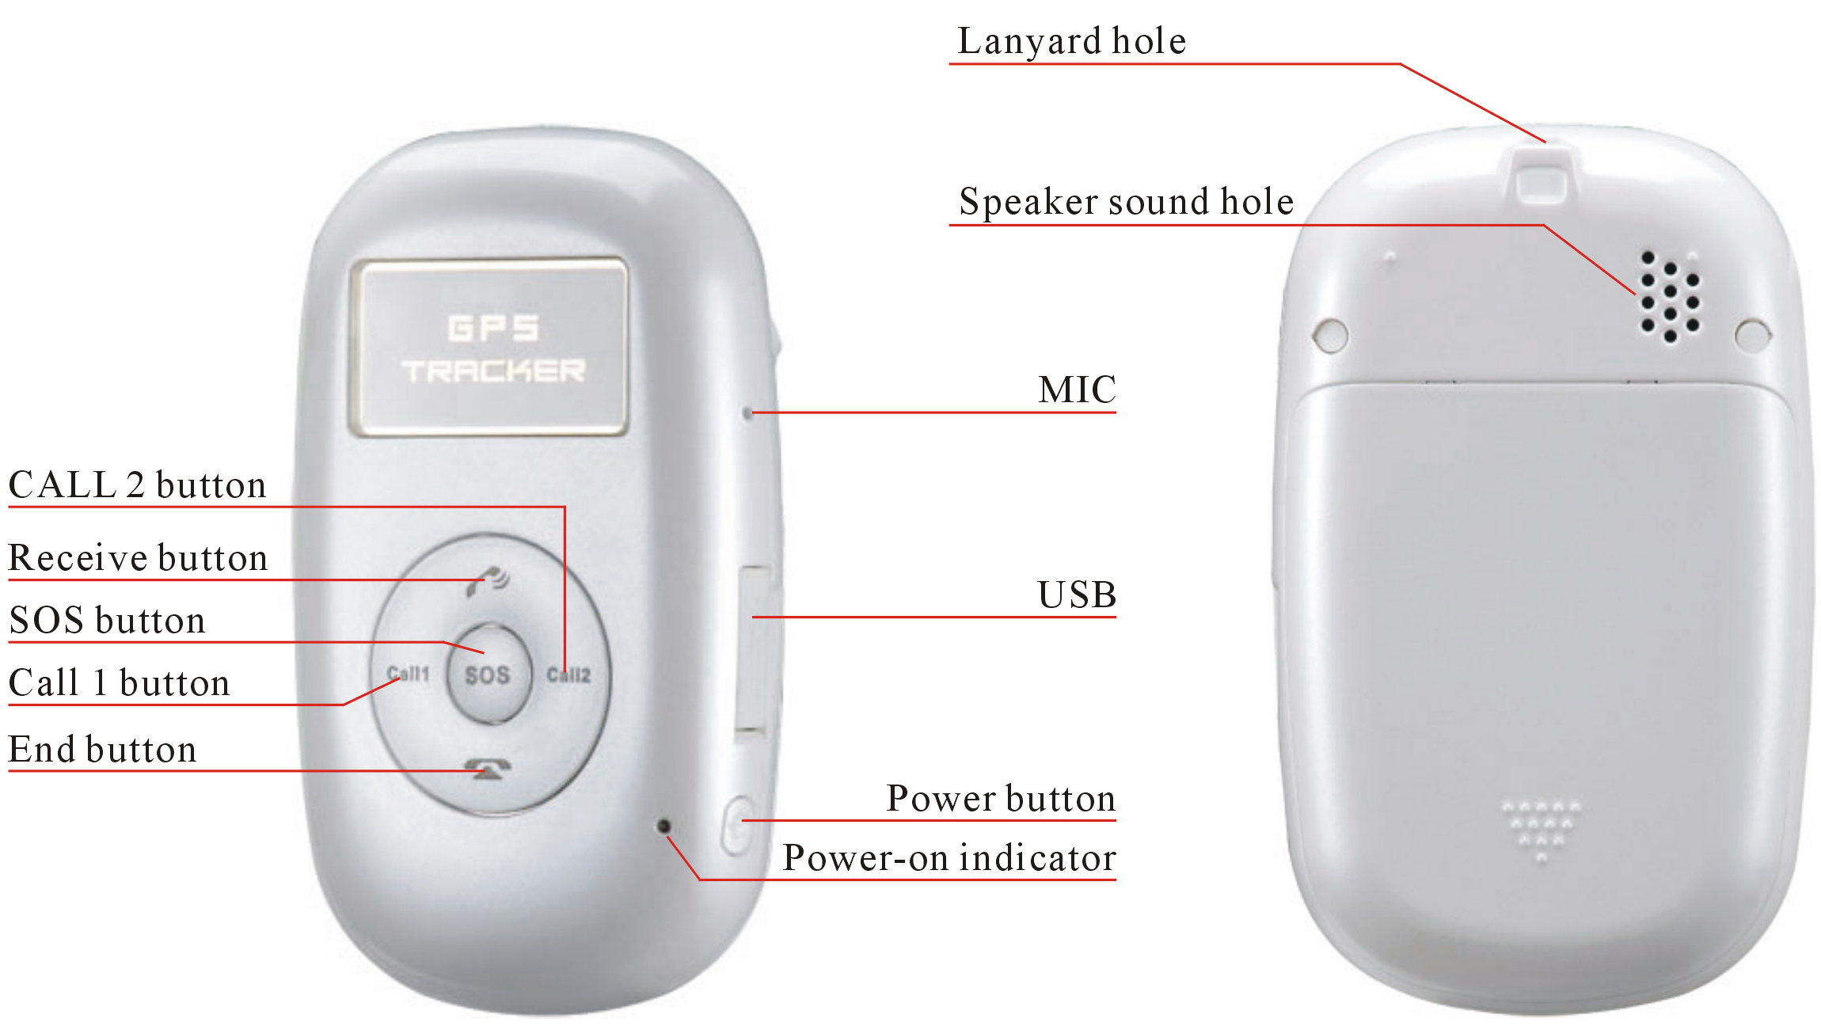

II. Charge the Battery
Before the use of the tracker, please charge the battery at least 4h via the USB charging cable. For the first charge, in order to bring the performance of the battery into full play, charge it above 12h.
Indicator of charging:
Red, being charged;
Green, charging completed.

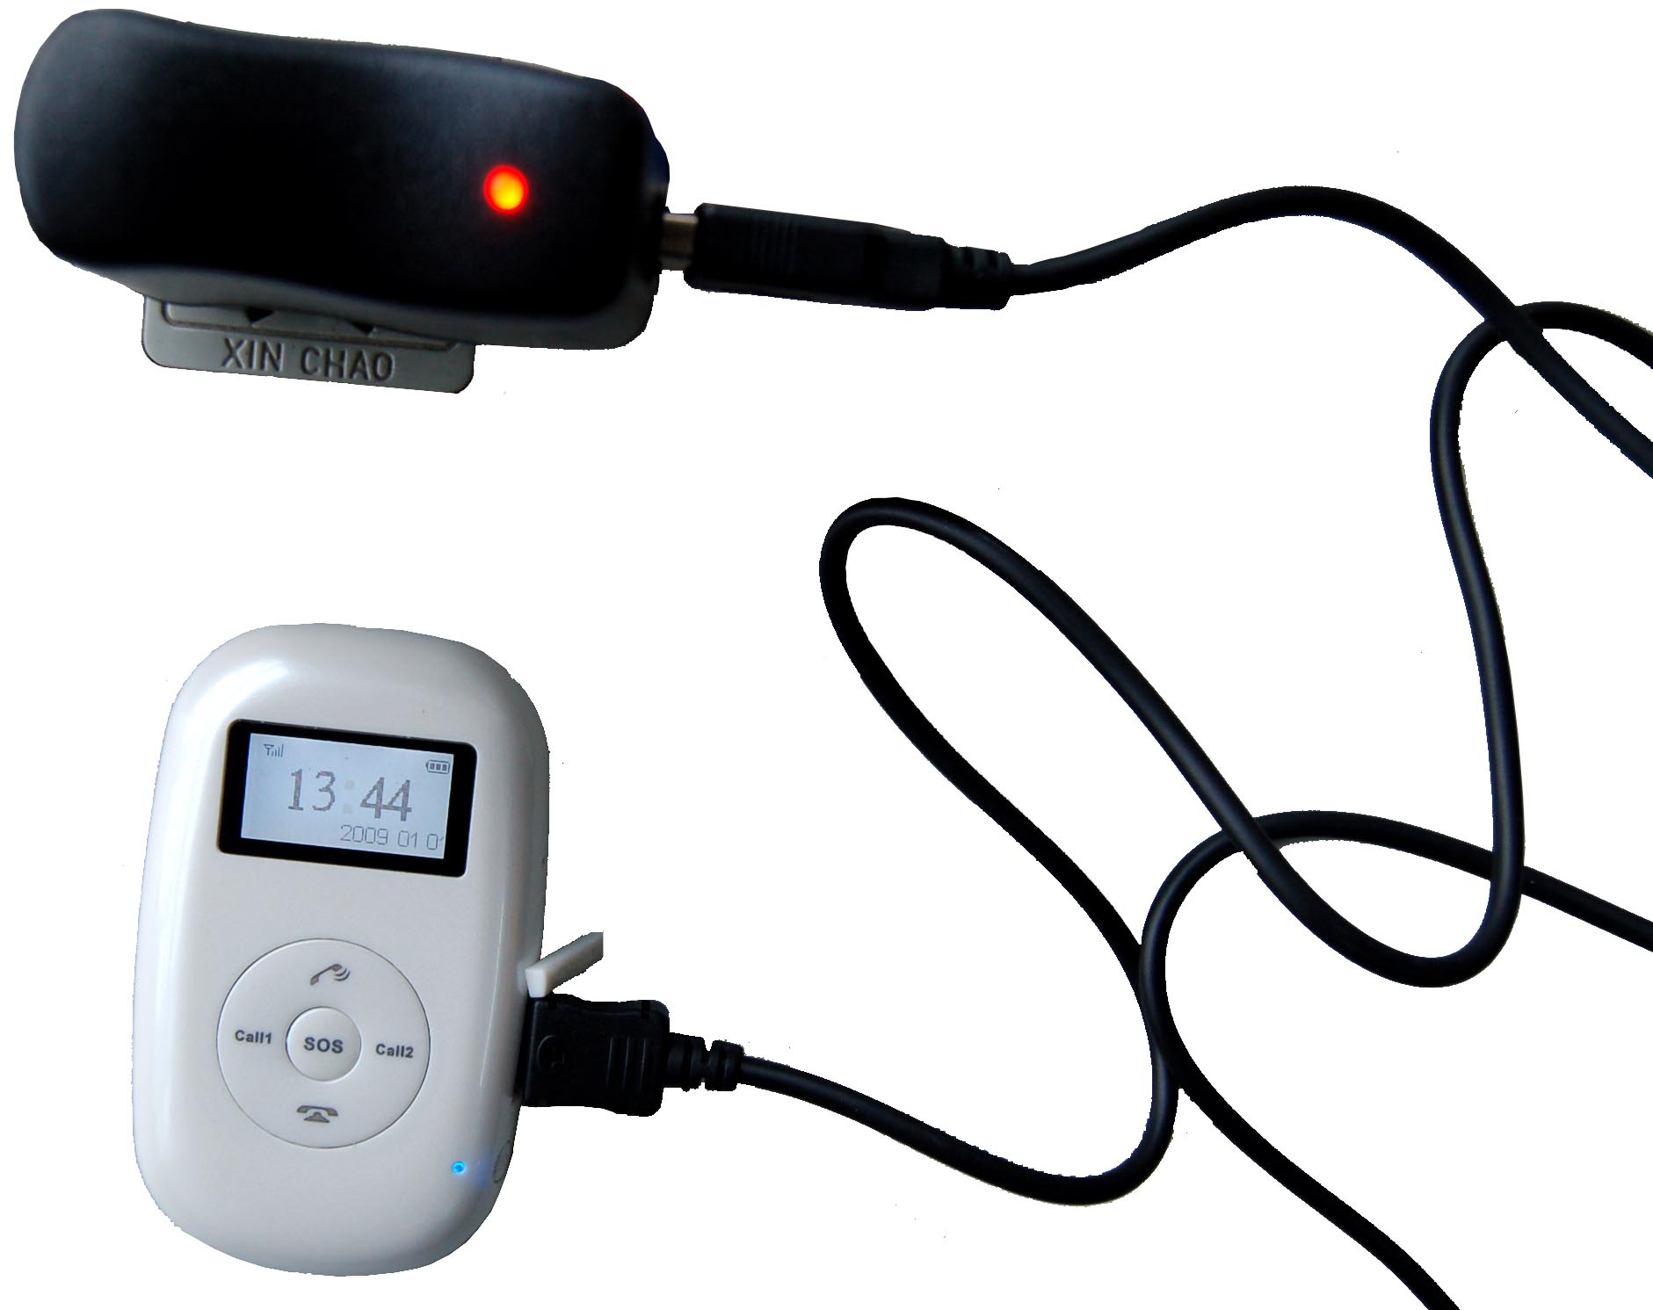

III. Installation of SIM Card
Open the back cover, then you will see the place where the SIM card is placed. Then push the SIM card into the slot until it comes into its proper position completely and make sure it is locked. See the following figures:

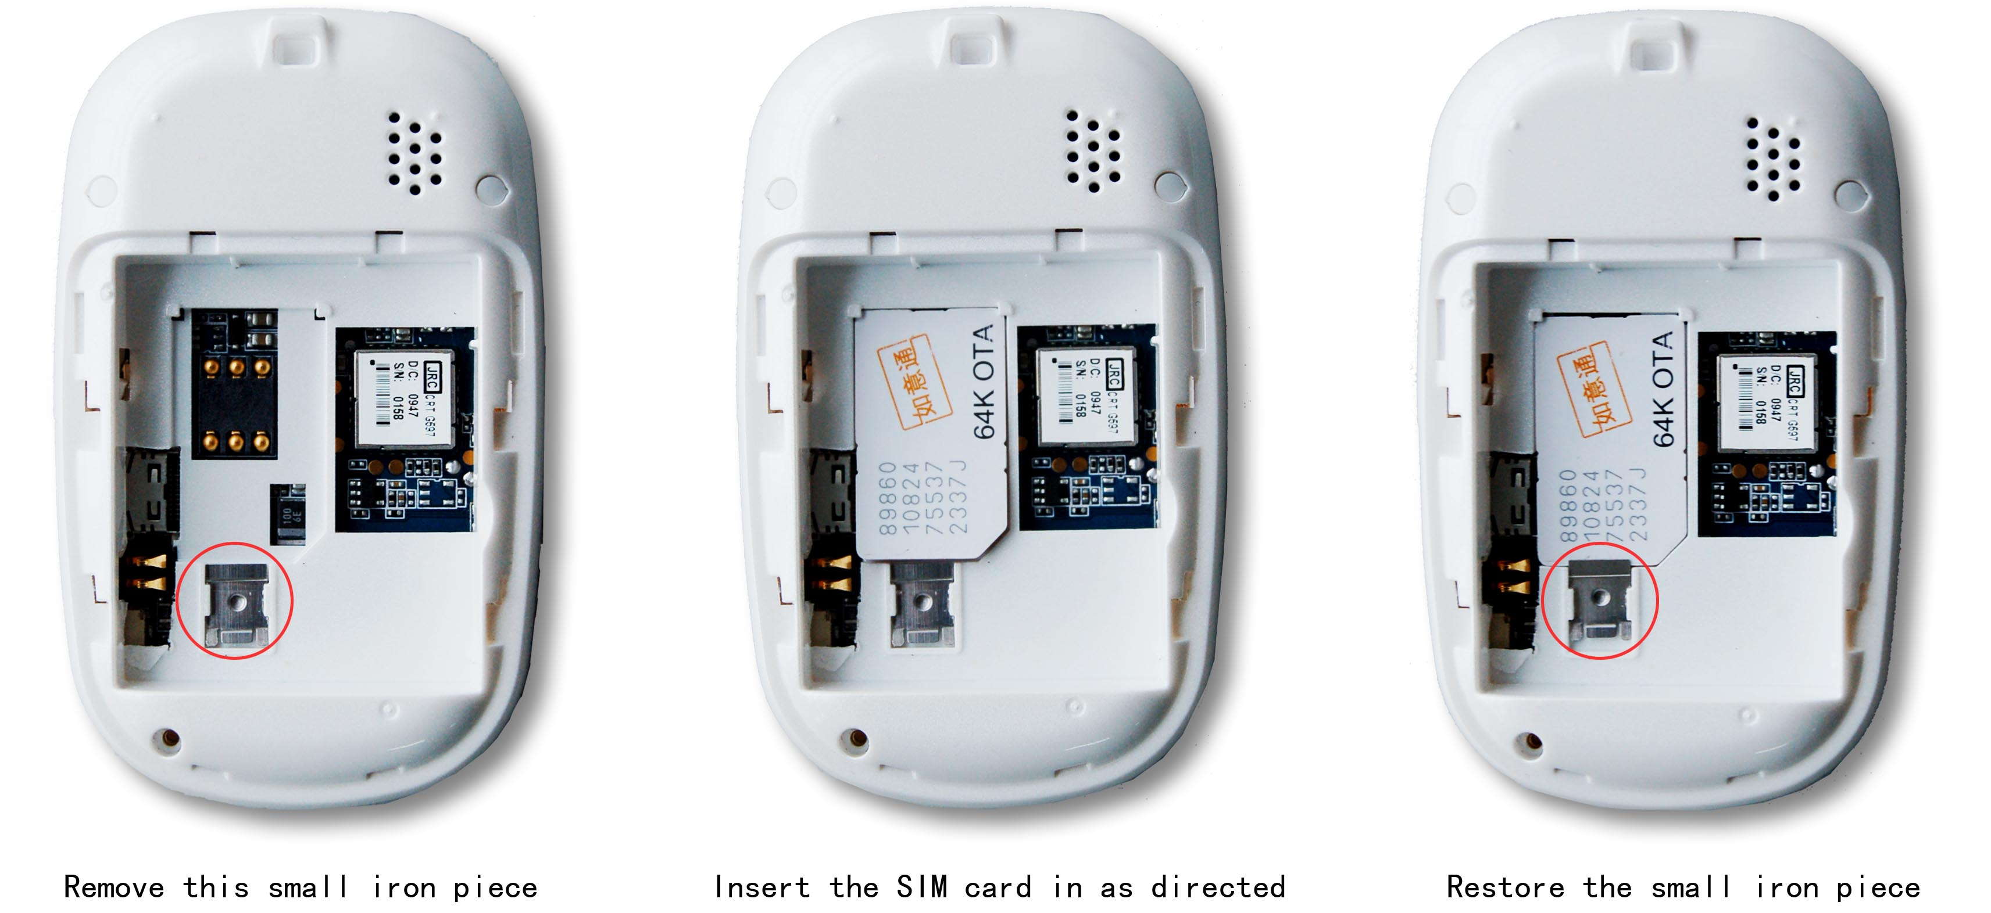
Choose SIM card:
- The type of the SIM card is GSM card (the SIM card of China Mobile is recommended).
- Make sure the SIM card has sufficient amount in order to pay the communication cost.
- Prepare one piece of SIM card for mobile phone (the SIM card of China Mobile is recommended), make sure that the card has opened such functions of Caller ID and receiving and sending messages. If necessary, use the service platform to track the GPRS function to be opened in real time.

Chapter IV Commands Corresponding to and Operation Method of Basic Functions

1. Location Inquiry

(1) SMS Inquiry
Create 666 + password command (defaulted password as 0000) via mobile phone and send it to the student terminal mobile phone number; after successful sending, the guardian’s mobile phone will receive a piece of word message. See the flow as follows:

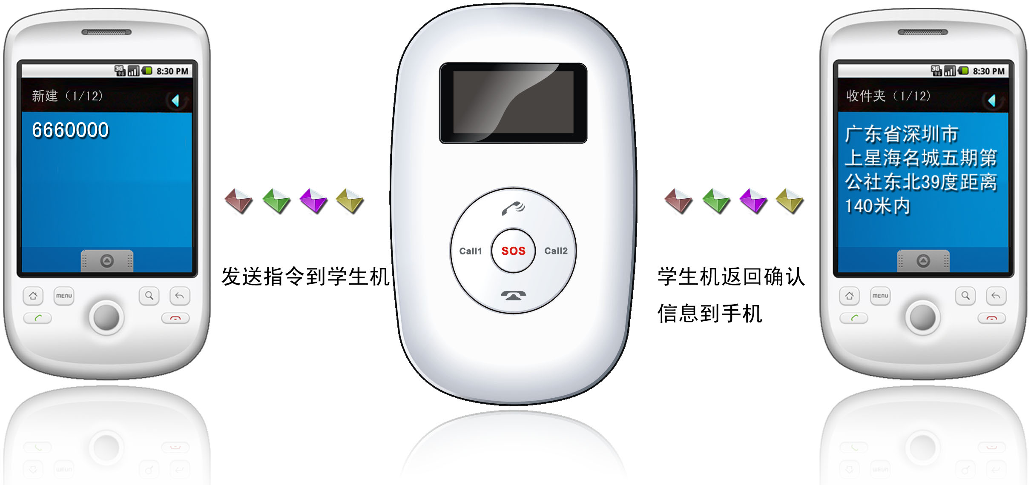

By the same means, send the command 987 + password to the terminal, then the terminal will return one piece of website message. The guardian may inquire the location information of the ward attached with local map through this website message.

2. Setup of Center Number
Set the center number by means of SMS through mobile phone. After the setup is successful, then the mobile phone sending the SMS will receive the “config OK” response message from the terminal.
Command format: #710# center number # user password ##
For example: #710#134xxxxxxxx#0000##
Note: All alarming information thereafter including SOS, low power, electronic fence, etc will be returned to such number.

3. Bi-directional Call Function
Send the command in form of SMS through mobile phone to the terminal. After the setup is successful, after sending the SMS, the mobile phone will receive the config OK response message returned from the terminal.

Setup format: #711# Call 1# Call 2 # Call 3 # 0000##
For example:

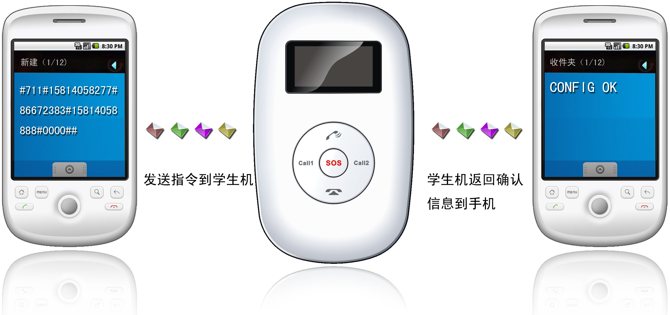
Note: After the setup is successful, press the CALL 1 button, then the terminal will automatically dial the first phone number. Press the CALL 2 button, then the terminal will automatically dial the second phone number. In addition, the terminal may receive all calls by pressing the Receive button and end all calls by pressing the End button.
Remarks: The automatic receiving function of the terminal. For all calls, if the terminal does not choose to end or receive within 30s, they can be received automatically.

4. SOS Function
If a ward number (the number in 3 above) is set, when the ward encounters emergency and presses the SOS button, then the terminal will send alarming information to the center number and dial three ward numbers in order.

5. Monitoring Function
The ward may send SMS 555 + password to the terminal of the ward; in such case, the ward terminal of the ward will automatically call back the mobile phone of the guardian and the guardian may listen to the sound of the surroundings within 10m around the ward.
SMS format: 5550000
Remarks: 0000 is the initial default password and the actual use s subject to the actual password.

6. Regular Upload Interval Setup
The defaulted factory upload interval of this device is 2 minutes for getting the point and 10 minutes for uploading one piece of positioning information. The user may change such parameter according to actual demand.
Command format: # command number 730# Sampling interval # Pieces of uploads # User password ##
For example: 730#20#4#0000##
Note: The parameter “20” indicates getting one point every 20s; after getting points accumulatively for 4 times, upload one piece of positioning information with the upload interval as 20*4=80s. The user may change this parameter as the case may be.

7. Function of Changing Password
Send the SMS “#770# User new password # User old password ##” by mobile phone to the terminal number, after successful sending, the mobile phone with such setup will receive one piece of config ok response information, as shown in the following figure:

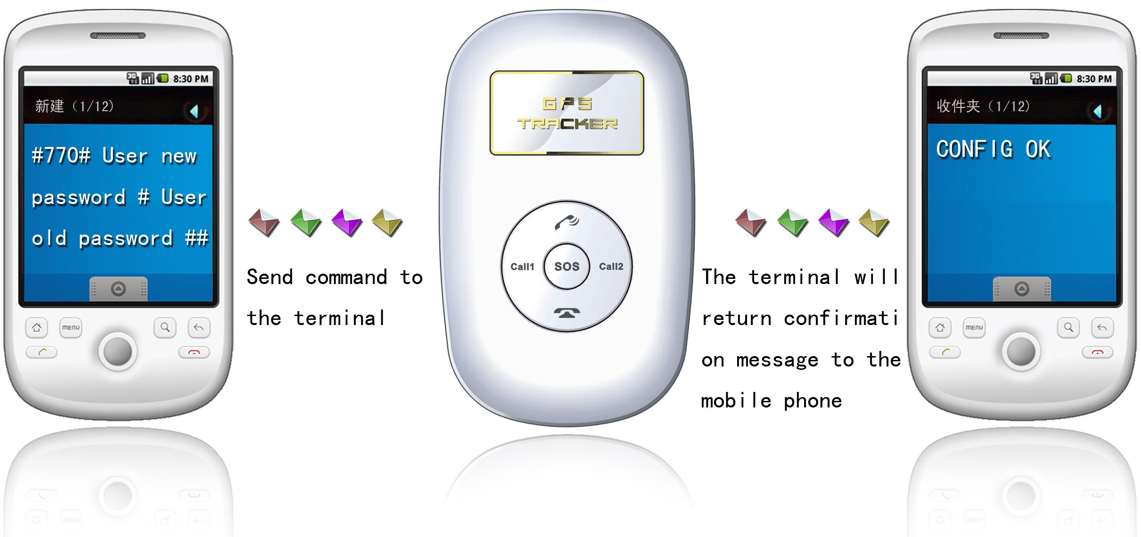

8. Low-Voltage Alarming Function
If the terminal of the ward has a very low power and needs to be powered off, the terminal of the ward will automatically upload one piece of low-voltage alarming command to the monitoring center number.

9. Set APN Command
Create the SMS “802#APN letters or digits, 4-20 bits # Log user name letters or digits 4-20 bits in # Log password letter or digits 4-20 bits in # terminal password 4 bits ##” and send it to the terminal; after executing this command, the terminal will automatically restart and connect to GPRS with APN set.
Command example 1: #802#cmnet###0000###
Command example 2: #802#CCDLEN#QIUXIA.21#RX0000#0000##
After this command is executed, APN will be CCDLEN; the login user name is QIUXIA.21 and login password is RX0000.
Note: The default APN of this product is CMNET.

10. Electronic Fence Function

(1)GPS Fence Function
The guardian may log into the system, click the custom deviation setup in the user system manager, enter the deviation setup interface, choose the longitude and latitude of the center point to be set as fence. Click the mouse in the Google map, then reading page will display the electronic fence with longitude and latitude set. See the figure below:
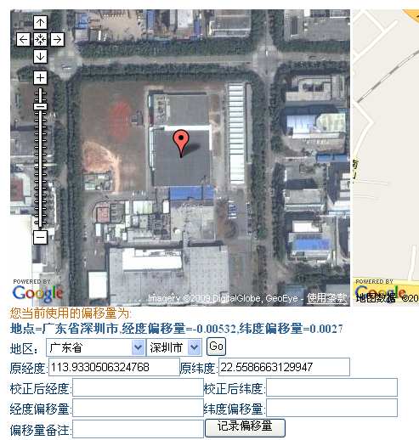
Set fence format: # command number (751) # fence radius # sampling interval # longitude # latitude # user password ##.
For example: #751#500#5#22.5442N#113.91E#0000##
After the setup is successful, the setting mobile phone will receive a piece of config ok command. Then, when the ward leaves this area, the terminal will send the alarming information of being out of the fence to the center number.

(2)GSM Fence Function
The ward may send # command number (740) user password 4 digits ## command to set the GSM fence. After the setup is successful, the terminal will return the message of CONFIG OK to the setting mobile phone, or the message of PASSWORD ER if the password is wrong.
For example: #740#0000##
Description of GSM fence: The terminal reads the GSM base station information, including that the main base station and the adjacent base stations. Take the first four digits and keep them in the module. If the base station has many data with different first digits, they all must be saved. And initiate the protection status. In the state of protection, the module will read the data of all base stations (1-7) once every 5 minutes, and take the first 4 digits to compare with the protection data. If all the first 4 digits of the data of all base station are consistent with the existing data, then dial or send alarming messages to the user according to the alarming setup.
For example: #740#0000##. After the fence is set, the terminal will alarm in the case where it is moved about 3-5km out of the fence.

(3) Fence Reading Function
Send commands to the terminal: # command number (752) # user password 4 digits ##; after the command is set successfully, the terminal will read the data of the module fence working status and return message to the sending mobile phone, or PASSWORD ER if the password is wrong.
For example: #752#0000##
Return: #open:1#lat:11456.209400#lng:2233.470100#distance:500#time:5#status:2
Where, open: 1 indicates fence open; Open: 0 indicates fence closed;
lat:11456.209400, latitude;
lng: 2233.470100; longitude;
distance: 500; fence radius;
time: 5 sampling interval;
status: 2 , terminal has obtained valid satellite data, fence works normally;
status: 1; fence open, but there are no valid satellite data have been received;
status: 0, no electronic fence is set.

(4) Function of Canceling Fence
Command name: # command number (760) # user password 4-digits ##
Example: #760#0000##
After the terminal receiving this command, all fence settings will be cancelled.
Advice； Do not set GSM fence and GPS fence at the same time.

11. Auxiliary Functions:
(1)#901## Command of reading user parameters;
(2)#902## Command of reading GPRS parameters
(3)#903## Restart command
(4)#904## GPRS connection command
(5)#905## GPRS disconnection command

Notices:
- This device is of non-waterproof design.
- This device must work with the cooperation of GSM/GPRS network.
- Make sure that the SIM card has sufficient balance in order to avoid inconvenience in use.
- This device will not be able to work in case of power-off and out of the service area, even if you are a registered user.
- This device supports the dual positioning mode of GPS and GSM/GPRS.
- Please use this device in a legal area, any illegal consequence will be borne by the user.

