Rear-Mirror GPS tracker+Car DVR user manual

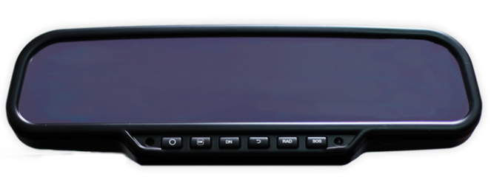

< <preface 3
< <technical parameters： 4
< <main features： 5
< <key interface 6
< <SMS command list ： 8
< <watch-dog features： 10
< <device accessories： 12
< <device installtion : 13
<< platform instruction： 14

< < Preface
Mirror vehicle tracker is a perfect design which enable video recording, transmitting image by SMS or GPRS, wiretapping, GPS tracking. With precise size and simple appearance, this product shows the advanced technology in the field of GSM and GPS.
As a company specializing in security and positioning, we will provide more and better products and services for you.
Prior to use, please take a few minutes to read this user manual, so as to know about the operational details and get better service.

< <Technical Parameters:
1、Dimension:
◆275(W)mm*84(H)mm*42(D)mm
2、power source:
◆9V-42V
3、power consumption:
◆working current：50mA-200mA
◆standby current：10mA-50mA
4、operation temperature:
◆working temperature：-25℃-+80℃
◆storage temperature:-40℃-+85℃
◆working humidity：20％-80％RH
◆storage humidity：5％-90％RH
5、HD camera:
◆Wide angel 120 degree
◆Car front lens pixels 2m pixel
◆Car inner lens pixels 1m pixel
6、short time to start:less than 0.1 seconds
7、Memory card：
◆support 2-16G memory card
◆support plug in and plug out
8、GSM frequency： 850/900/1800/1900MHZ
9、GPS model:SIRF chipset,sensitivity: 148dBm cold start: 165dBm

< <Main Features:
- Wiretapping function
- Tracking in real time by SMS or GPRS
- Tracking by either computer or mobile phone
- Car-DVR function for both inside car or front of car ,
- the mirror are continuously and automatically recording the video of front car once the ACC is on . as a blackbox .
- to display the recorded video in Screen of mirror when ACC is off .
- this function can be enabled or disenabled by SMS or GPRS remotely
- 2.8inch LCD in the rear mirror
- To take the photo and display , to display the recorded video
- To view
- the incoming message which is transmitted from server
- Two way conversation
- Auto-voice guide .pls follow up the voice guide to operate .
◆ firstly pls input the password . the default password is 123456
◆ pls press 1 to enter in two way conversation automatically
◆press2 to acquire the current position by SMS
◆press3 to acquire the imagine of front view in the car
◆press 4 to acquire the imagine inside the car
◆press 5 to active the video recording in the front of car
◆press 6 to active the video recording inside the car
◆press 7 to change the password
8、.alarm :
◆SOS
◆Geofence
◆overspeed
9. report
◆Milege report for daily and monthly
◆ACC status report
◆overspeed report
13、Built-in watch dog function
14、Recording function:
◆support TF card
15、SOS Key
◆pressing SOS key, it will send SOS message to the preset authorized phone.
16、Black box

< <Rear-mirror key interface:

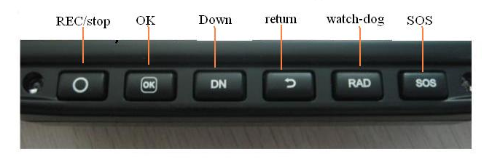

1、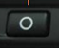:start and stop to video .
2、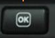:a confirmed key when it enters in operational interface.
3、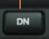: up and down key in manue
4、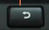 : turn on the LCD when the ACC is on or OFF . and back up to last manual .
5、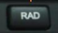: in D07 model , this button is to turn on and off Watch dog function by pressing for 3 seconds until u hear the voice . in model D08 , this button is up . this button is active no matter ACC is on or off .

- 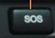: SOS button is to send SOS alarm to both server and preset phone number , meantime to make a call to preset phone number .

Note : button 1,2,3 can not be active when ACC is on . only be active when ACC is OFF for driving security purpose .

< < SMS command list:
（default password:123456）
1、Set authorized alarm No.
command:ZE0003Cphone No.#
For example：sending "ZE0003C15012761212# "to device and then mobile phone will receive message"ZE0003C15012761212,OK#"
Description: this binded number will receive SOS call and SOS alarm only.
3、check the current authorized alarm number
command:ZE0004Q#
For example：sending "ZE0004Q#" to device and it will be return message as following:
3.1、"ZE0004Q，15012761212,OK# "will be replied when it has already set the sending alarm No.
3.2、"ZE0004Q，WUHAOMA,OK#" will be replied when the alarm number are not preset
4、Reset device
command:ZE0001CQ#
For example：sending"ZE0004Q#" to device and mobile phone will receive "ZE0001CQ,OK#" message and after got the message, the device will restart automatically within 2 minutes.
5、Setting date and time
command:ZE00020DdateTtime#
For example：sending "ZE00020D120303T145123#" to device and mobile phone will be received"ZE00020D120303，T145123,OK#" as well as updating time.
6、acquire the current position
command：ZE0005WZ#
For example：sending"ZE0005WZ# "to device，and current location will be send to the mobile phone
7、acquire the front car imagine
command：ZE0013QM09#
For example：sending " ZE0013QM09#" to device and mobile phone will receive "ZE0013QM09,OK#" and the rear mirror will active front camera and take picture and transmit imagine to the phone by MMS
8、acquire indoor pictures
command：ZE0013QM10#
For example：sending"ZE0013QM10#" to device and mobile phone will receive "ZE0013QM10,OK#" , the indoor camera will be active to take in-car picture and transmit to the phone by MMS
9、oil cut-off
command：ZE0017B0E#
For example：sending"ZE0017B0E#" to device,and mobile phone will receive"ZE0017B0E#,OK#" . after the oil will be cut and stop the car
10、recovery the Oil/engine on
command： ZE0018R0E#
For example：sending"ZE0018R0E#" to device and mobile phone will receive"ZE00180E#,OK#" . after the oil /engine will be recover to work in normal .
11、Delete preset alarm No.
command： ZE0019DN1#
For example：
11.1、sending"ZE0019DN1#" to device and mobile phone will receive "ZE0019DN1#,OK#. After the first preset alarm number are deleted . 11.2、sending "ZE0019DN2#" to device and mobile phone will receive"ZE0019DN2,OK#" After the second preset alarm number are deleted 11.3、sending"ZE0019DN#" to device and mobile phone will receive"ZE0019DN,OK#" . that mean all the preset alarm number has been deleted successfully .
12、Set interval for recording video (30 minutes as default)
command:ZE0021SVTtime#
For example:sending"ZE0021SVT060#" to device and mobile phone will receive"ZE0021SVT060,OK#" , that mean u already successfully set the interval of recording video by 60min . after the the video will be keeping recording for 60 min and compressed to one file . .
13、start to Record outdoor video
command：ZE0022VOUT#
For example:sending"ZE0022VOUT# "to device and mobile phone will receive"ZE0022VOUT,OK#", after the video will be started to record in the front of car .
14、start to Record indoor pictures
command：ZE0023VIN#
For example:sending"ZE0023VIN#" to device and mobile phone will receive "ZE0023VIN,OK#" after the video will be started to record inside car .

< <Watch dog features：
- after the device acquiring the gps , it will automatically detect the surroundings road data such as the ove-rspeed threshold, if there is camera beside , if there is red-green light in the front , after the device will speech remind the driver the information .

*System default setting：
speed：20Km
mode：safe driving mode
Sensitivity：radar
Over speed：no speed limit
Speed adjustable：0

- Voice instruction
 | Introduction | content and meaning
1 | Power on | Ding dong -----please fasten ur seat belt
2 | GPS fix | GPS fixed
3 | Red-green light detection and over speed detection | Ding ding ding ding----- there is red-green light in the front of you , pls drive carefully .. overspeed threshold is xx
4 | Overspeed detection | Ding ding ding ding------ there is Radar detecting the overspeed beside of your car ,pls drive carefully . overspeed threshold is xx XX kilometers limited
5 | Mobile police car surroundings detection | Ding ding ding ding------ police car always available in this area . pls drive carefully . overspeed threshold is xx
6 | Camera in the bridge detection | Ding ding ding ding------ there is camera in the front of bridge . pls drive carefully . overspeed threshold is XX
7 | Flow over speed detection | Di di di. detecting radar signal. Di di di di .......
8 | Cctv monitoring surroundings | Ding ding ding ding-----there is camera beside your car
9 | Bus road | Ding ding ding ding------the front way is for bus use only . there is camera beside .
10 | toll station | Ding ding ding ding------ toll station existing
11 | rest stop | Ding ding ding ding------rest stop existing
12 | gas station | Ding ding ding ding------ gas station existing
13 | tunnel | Ding ding ding ding------ tunnel existing
14 | school routine | Ding ding ding ding------school routine
15 | high frequency position | Ding ding ding ding-----high frequency position existing
16 | railway crossing | existing railway crossing
17 | no parking | Ding ding ding ding----no parking
18 | 50-100m distance to take picture | dang dang
19 | over speed | Gu gu ......
20 | Time reminding | Dang dang-------now is XXX time
21 | invalid key | Ding ding ding.....
22 | fatigue driving notice | please take a nap

3、GPS abnormal status
★for position of warning point ☆for position of removing point
- Distance<50m of two parallel road may misstatement.
- The equipment removed but no updated data would cause misstatement.
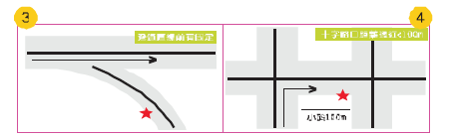
- Crossing point would be caused misstatement.
- distance <100 meters of turning point would not be reported.
- The long distance of tunnel,which warning point is in the exists and disenabled to fix GPS
- The overlap viaduct would be caused misstatement.

< <Device Framework:
(850/900/1800/1900MHZ)GSM/GPRS mode.built-in GPS and GSM antenna, and having car DVR function.

< <Device Accessories:
01、one terminal device(built-in two camera)
02、Power cord (200cm 1PCS )
03、one SD card（2G)
04、warranty card
05、security certificate
06、user manual
07、security label

< <Device Installation:
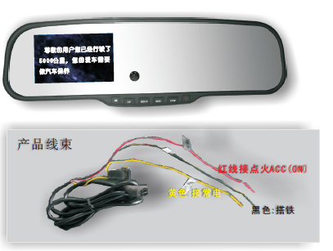

一、preparation for installation：(please checking the circuit)
1、pls insert the SIM card correctly . pls be sure your SIM card support GPRS and incoming call display
2, pls check the car original rear –mirror holder is ok . and pls select suitable holder according to your car model to fix the rear-mirror .

For installation , pls refer to the installation instruction .

