Vehicle GPS Tracker
User manual
V7.2

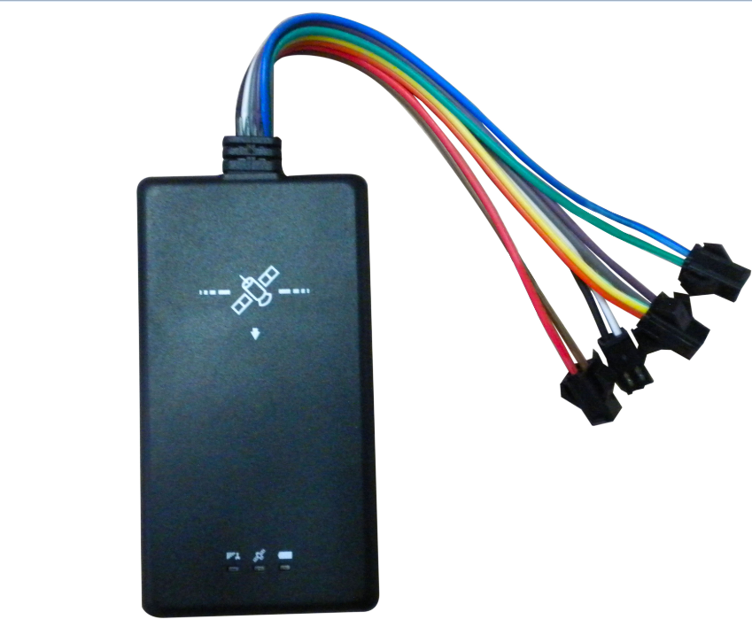

Updated on 2013/04/22

This Tracker provides peace of mind by showing you with your mobile phone or PC the location of your targets via SMS or GPRS.

TRACKER has the following Main features
- Real-time Tracking via SMS or GPRS
- Support GPS and LBS
- Tracking by time interval
- SOS alert
- Geo-fencing control
- Over-speed alert
- Alert when Track enter/exits GPS blind area
- Live voice monitoring
- Vibration alert
- Advanced Static drift
- Anti-theft function
- Support TTS function
- Support MIC , SOS , SPEAKER , IMMBOLIZATION , ACC .
- Mileage report
- Wide operating voltage form 5.5V to 40V

- Parameters& Panel Description
Item | Specification
Voltage | 5.5-40V
Operating temperature | -20° to 65° C
Humidity | 5% to 95% Non-condensing
GSM module | MTK6252
GSM Frequency | GSM 900/1800/1900Mhz/850mhz 4 bands
GPS Chipset | MTK3326
GPS Sensitivity | -158Db
GPS Frequency | L1, 1575.42 MHz
GPS Channels | 20 channel all-in-view tracking
Position Accuracy | 10 meters, 2D RMS
Velocity Accuracy | 0.1 m/s
Time Accuracy | 1 us synchronized to GPS time
Default datum | WGS-84
Reacquisition | 0.1 sec., average
Hot start | 1 sec., average
Warm start | 38 sec., average
Cold start | 42 sec., average
Altitude Limit | 18,000 meters (60,000 feet) max.
Velocity Limit | 515 meters/second (1000 knots) max.
Acceleration Limit | Less than 4g
Jerk Limit | 20 m/sec
LED | 3 LED indicators showing power, GPS, GSM status and other operation status.
G-sensor | ±2g
SIZE | 85*46*10mm

Panel Description
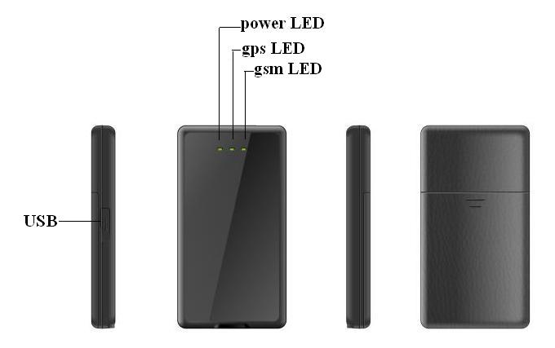

Back cover printing :
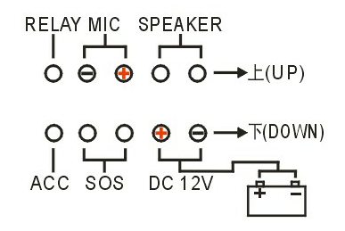
2. Product Overview
  - check part list
before starting , check all the following items have been included with your I86 , if anything is missing , please contact your supplier
Items picture | Name | Description
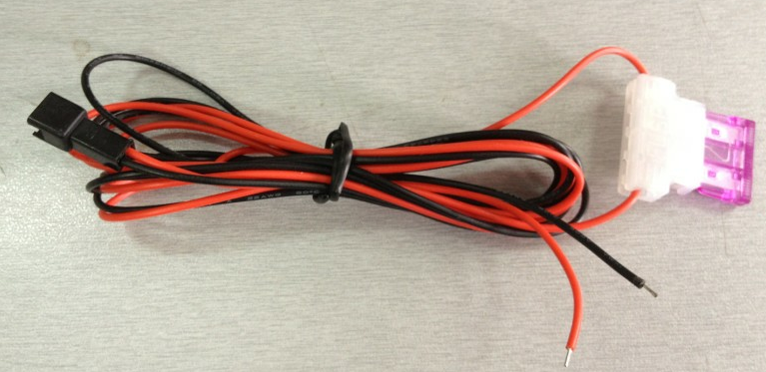 | Extended Power wire with length of 1.5M | the red indicate the positive , the black wire indicate negative (GND). The wire is with Fuse included ,which is to protect the device being burned .
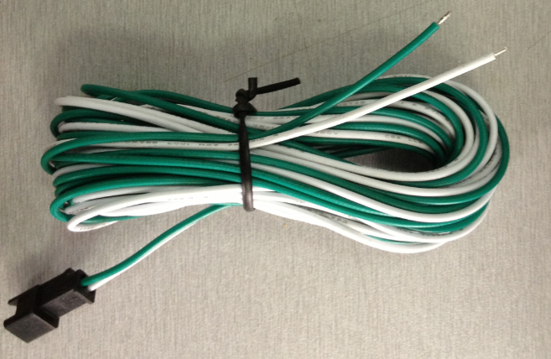 | Extended ACC wire with length of 1.5M | Green wire indicate ACC , white wire is for GND .( GND is not necessary to connect )
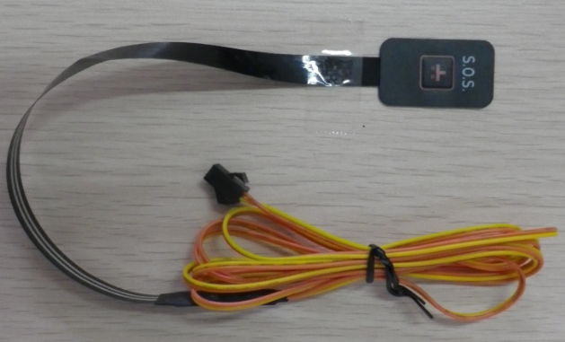 | Panic button with length of 1.5M
 | User manue

  - Interface Definition
The I86 has 10 pin interface connectors . it contains the connector for power , SOS, ACC, Speaker, Microphone, relay . the sequence and definition of the 10pin are shown in the following figure:
3. Getting started
3.1 open the back cover and insert SIM card
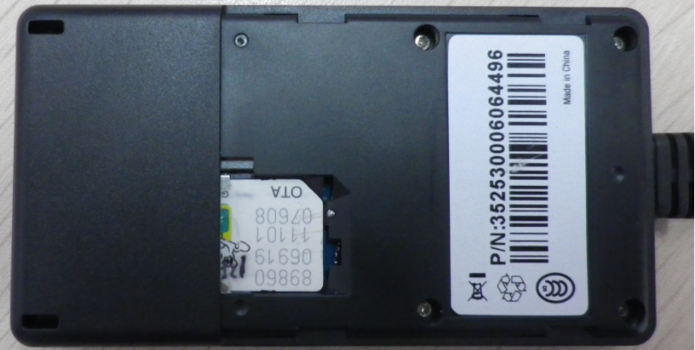
3.2 wire connection
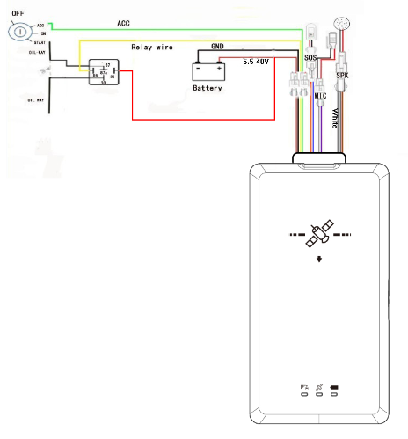

4. LED indication instruction :
Device has Three LED lights with three different colors to indicate the status of the unit.
Red led-indication power status

Green led-indicating gps status
Off | Device is not ready
flashing in 0.05 seconds and 4.95 seconds off | GPS fixed
Flashing(on for 1 second and off for 4 seconds) | GPS not fixed

Blue led-indicating GSM status
On | when call is coming in / call is being made/GPRS transmitting
Flashing (on for 0.05 second and off for 4.95 seconds) | Track is connected to GSM network
Flashing (on for 1 second and off for 4 seconds) | Track is not connected to GSM network
Note: when the device is on, if it is not insert SIM card or abnormal SIM card, the three LED would be continuously flashing in sequence

5 SMS command
The device only reply to command with valid password . Factory setting password is 000000.
5.1 Basic SMS command
5.1.1 current location required command :
Description：if u need to know the current location of the tracker, kindly send the following
Command: W<password>, <000>
Note: default password is 000000.
For example:
Sending SMS: W000000,000
Receiving SMS: W00,000,$GPRMC,034522,662,A,2232,3126,N,11359,3061,E,000.0,000.0,241209,,,A*6E

5.1.2 authorize SOS phone NO.（SOS key is an optional accessory)

Description：binding the phone No.for SOS. When press the SOS key, it will send SOS message alert to the binded phone No.
Command: W<password>,003,F,P, T

Note:
(a) F =0, to turn off this function
=1, only sending SMS
=2, only calling the preset phone No.
=3, Both SMS and Calling
P =1, set authorized No. for SOS button
T, preset phone No.

(b) When long press the SOS key, it can send message to the preset phone

Example:
Sending SMS: W000000,003,1,1,123456789
Receiving SMS: W01,003,Set phone number OK
Remarks: when long press SOS key, SOS message will be sent to“123456789”。

5.2 GPRS Settings by SMS
Tracking via GPRS, you should set APN for Tracker
Ensure that your SIM card in Track supports GPRS connection prior to setting.

5.2.1 Setting APN
Command: W<password>,011,<APN>,<APN user name>,<APN password>,<APN DNS>,<APN second DNS>
Note: If no APN name, APN password, APN DNS and APN Second DNS required, input APN only.
Example: W000000,011,CMNET
TRACK will reply with an SMS (like ‘W01,011, Set device APN OK’) to confirm this setting.

5.3 Setting for Anti-theft function
5.3.1 To enable this function
Sending SMS to the preset No. to binded the sos key is to enable the anti-theft function（pls refer to the setting of preset phone No. for SOS button)
5.3.2 Setup defense
After successfully sending”SF” to device to setup defense, the device will enter into the security status with one minute delay. Once the vehicle is moved or vibrated illegally, the message alarm will be sent to the authorized No.
5.3.3 Cancel defense
After successfully sending “CF” to device to cancel defense, the device will be back to normal status.
5.3.4 Get position
sending command ”DW” to device, the tracker will reply the current detailed location
5.3.5 Get position in coordinates
Sending command” DWJW” to device, the tracker will reply with the position data(coordinates and cell information) .

6 SMS command list
Note: ****** is password，factory setting password: 000000.
Description | Command | Remark
Get current location(NMEA) | W******,000 | Get current location of tracker in NMEA format
Get current location(Google Earth) | W******,051 | Get current location in Google Earth format
Get location in detailed address | W******,052 | Get current location in detailed address
Change user password | W******,001,###### | ****** is old password  ###### is new password
Set preset phone number for SOS button | W******,003,F,P,T | F=0, to turn off this function;  F=1, only sending SMS;  F=2, only calling preset phone number;  F=3, both SMS and calling (default)  P=1, set a authorized number for SOS  Button  T: Preset phone number. Max. 16 digits
Adjust G-sensor sensitivity | W******,017,XX | XX=01-15，default is 02  01 is for the maximum,15 is for the minimum

Presetting by SMS for GPRS tracking (Ensure that your SIM card supports GPRS connection prior to setting)
Set APN | W******,011,APN,APN Name,APN Password,APN DNS,APN Second DNS | If no APN name and password  required, just insert APN only;
Set character for SOS alert message | W******,033, P,Char | P=1, SOS key  Char is the character in SOS message and max 32 characters
Restore factory setting | W******,048 | Restore factory setting
Got location in Google link | W******,100 | Got location through Google link
Get version and serial  number | W******,600 | To get version and serial  Number of current firmware
Get IMEI | W******,601 | To get IMEI
Immbolization | W000000,911,1(0) | “1” indicate to enable engine cut , “0” indicate to disenable engine cut.
Setup defense | SF | Binding SOS key to enter into security mode.
Cancel defense | CF | Binding SOS key to disenable the security mode.
Get position | DW | Binding SOS key to get detailed current location

Note 1

Message return format: W**,###
** Error code
### Prompt No.
Error code description :

00: Get ok
01: Setting ok
02: Setting fail
03: Message format error
04: Password error
05: Prompt No. error
06: Modify password error
07: Parameter data error
08: No GPS data
09: Not support protocol
10: over-speed
11: Beyond the field
12: GPS invalid data
13: Open port error
14: Over-time
15: Refuse
16: Get GPS data error
17: Memory arrange error
18: Auto alert
19: GPRS ok

