JS810 Mini GPS Vehicle Tracker
User Manual

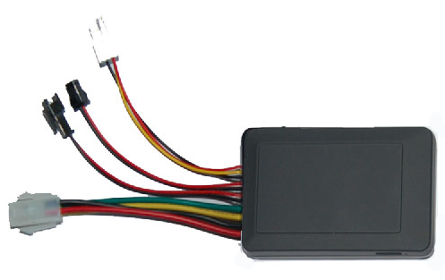

I. Foreword

1. Overview
JS810 vehicle tracker is the perfect combination of GSM communication technology and GPS satellite positioning technology. With precise size and simple appearance, this product shows the advanced technology in the field of GSM and GPS.
As a company specializing in security and positioning, we will provide more and better products and services for you.
Prior to use, please take a few minutes to read this user manual, so as to know about the operational details and get better service.

II. Precautions
1. Please read this manual carefully for correct operation.
2. You need to ask a professional to install this product in a safe position of your vehicle. Avoid dangerous or unsuitable positions, otherwise, harm to the driver or passengers may occur.
3. This manual is just for your reference. The contents and operating steps described in this manual may be different from that of the actual product, please refer to the actual product.

II Equipment Introduction
This vehicle tracker is a remote vehicle positioning device consisting of a GPS module and a GSM/GPRS module, which is featured by compact size, good concealment and high precision. It can provide the GPS satellite positioning information, and can also provide the positioning information supported by the GSM base station if the GPS satellite information is unavailable, and the information about the latitude and longitude coordinates can be sent to the system platform and the preset mobile phone number. You can make use of these features to locate and manage your vehicle.
1. Definition of buttons and external wiring
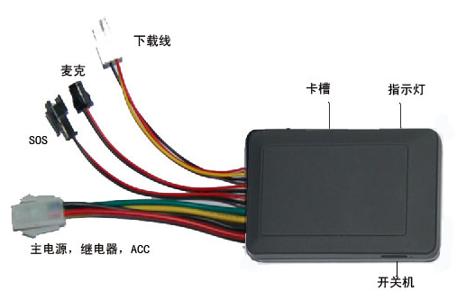
Card slot
Indicator
On/Off
Downloading wire
MIC
Power cord, relay, ACC

2. Installation of SIM card
There is a SIM card slot on the vehicle tracker. Insert the SIM card into the slot as illustrated below:
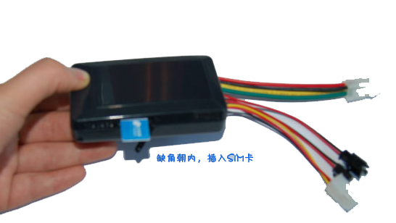
Insert SIM card with beveled corner inward

Note:
• The SIM card shall be GSM card (It is suggested to use China Mobile SIM card).
• Make sure to keep enough money in the SIM card account.
• Make sure the Caller ID Display function and SMS service of the SIM card have been subscribed for. To use the real-time tracking by service platform and positioning by SMS, the user has to subscribe for the GPRS service.

3. Wiring precautions
1. Power supply, ACC, relay (4-PIN)
1) The standard power supply of the equipment is 9V-58V DC. Please use the factory supplied power cord, the red wire is the positive wire, and the black wire is the negative wire. When connecting the negative wire, please ground it separately, and do not connect it to other ground wires;
2) ACC wire (green) is used to connect to the vehicle ACC switch. Be sure to connect the ACC wire, because the vehicle tracker will decide whether to enter the security status depending on the ACC switch status; if the ACC wire is not connected, the vehicle will be kept in the security or sleep status. Under the status of security or sleep, if vehicle vibration occurs, the vibration alarm will be triggered. If anti-theft alarm function is not required, you can connect the ACC wire with the positive wire in parallel to maintain high electrical level.

4. Description of special functions
1) Security function
If the ACC wire is connected to the ACC switch, this equipment will start the security function automatically in five minutes after the vehicle engine is turned off. If vehicle vibration occurs within one minute, the equipment will enter the security status with 1 minute delay, and will enter the security status unless no vehicle vibration occurs.
2) Sleep mode
After entering the security status, if no vehicle vibration occurs within 20 minutes, this equipment enters the sleep mode. In the sleep mode, this equipment neither locates nor uploads data, but can send/receive messages and make/answer calls, so as to achieve maximum energy saving.
3) Vibration alarm
Under the security status (including the sleep status), if vehicle vibration occurs, this equipment immediately disconnects the relay and dials the mobile phone number of the vehicle owner to give an alarm; meanwhile, it wakes up the GPS positioning, and uploads the alarm and location data to the service platform.

5. Definition of indicators
Red indicator () refers to the GPS status
Status | Meaning
Flash at intervals of 1 second | No GPS signal
Flash at intervals of 4 seconds | GPS normal positioning

Blue indicator () refers to the GSM/GPRS signal status
Status | Meaning
Flash evey 10 seconds | Normal connection to the server for data uploading
Flash evey 4 seconds | GSM normal standby status
Flash evey 1 second | No GSM signal/initialization/call in progress/incoming call

6. Operating environment
Operating temperature | -20---65℃
Humidity | 5%---95%
Dimensions (mm) | 90*53*21
Input voltage | 9V - 58V
Average current in standby mode | Less than 80MA

III. Query by SMS
Send the message 9880000 to the terminal using a mobile phone, and then the terminal will return a message about the location

VI. Query by Global Positioning Service Platform
The factory-set platform query function of the terminal is on, and the default platform address is jzdw.gps99.net, and the uploading interval is 60 seconds.
Note: If you need to change the platform address and the uploading interval, please refer to the 830 and 730 instructions described in the annex respectively.
Platform address: JZDW.GPS99.NET
User name: IMEI number at the back of the equipment (or directly provided by the operator)
Default password: 123456
Note: This function requires the support from the network operator, and the GPRS function of your SIM card has to be subscribed for.

V. Description of Accessories
(1) Power cord
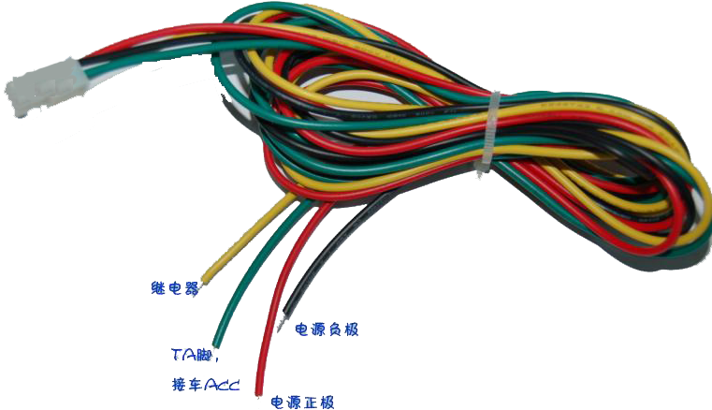
Negative wire
Positive wire
Relay
TA pin
Connection to vehicle ACC switch

(2) SOS button (optional) (3) MIC (optional)

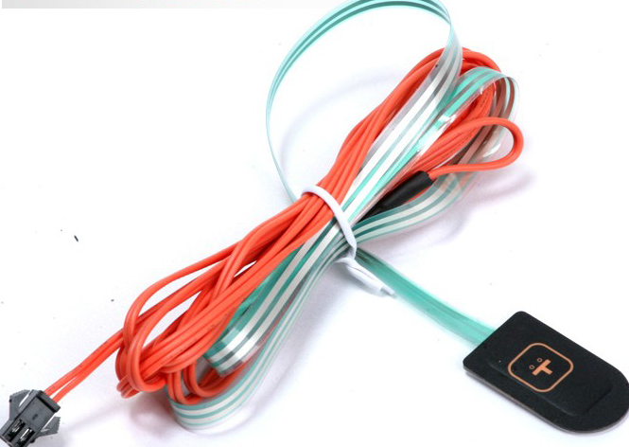

(4) Relay (optional)
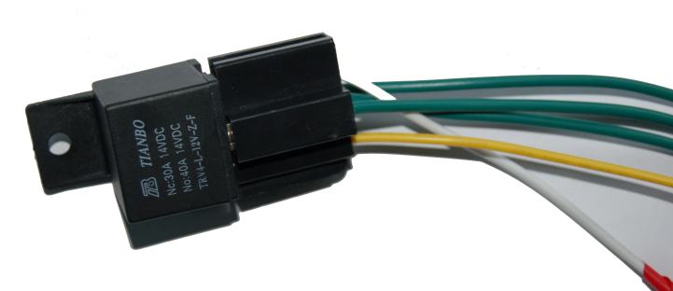

Annex I Instruction Set
Instruction | Description
#710#center number#user password ## | Set the center number.  Set the center number through the message sent by a mobile phone. After successful setting, the terminal returns “&710&Config OK&&”.  e.g.: #710#134xxxxxxxx#0000##  Description: The SOS alarm and low battery alarm messages will be returned to the number.
#711#phone number 1#phone number 2 #phone number 3#user password## | Set a preset number  Use a mobile phone to send the setting instruction to the terminal. After successful setting, the mobile phone will receive the message “&711&CONFIG OK&&” returned by the terminal.  e.g. 1: #711#134xxxxxxxx###0000## (The format of setting one preset number)  e.g. 2: #711#134xxxxxxxx#158xxxxxxxx#150xxxxxxxx#0000## (The format of setting three preset numbers)
6660000 (0000 is the factory-set user password, which can be changed) | Single location query; a message about the latitude and longitude will be returned
9880000 (0000 is the factory-set user password, which can be changed) | Single location query; a message about the specific location will be returned.
5550000 (0000 is the factory-set user password, which can be changed) | Monitoring function  The guardian uses a mobile phone to send the message instruction “5550000 (0000 is the user password)” to the vehicle tracker. Upon receipt of the instruction, the vehicle tracker dials the number of the mobile phone which has sent the message instruction. After the call is connected, the vehicle tracker enters the monitoring mode.  Note: The monitoring function can be used only when a preset number and the center number are set. For the center number setting and the preset number setting, please refer to the 710 and 711 instruction setting formats described in the Instruction Set respectively.
#567#year, month, day#hour, minute, second #user password (4 digits)## | Time setting instruction  e.g.: #567#110513#125820#0000##  Through sending this instruction, the user can change the one-key time announcement.
#730#sampling interval (0 or 15-65535 seconds)#number of pieces of data uploaded (0 -10)#user password## | Set the timed data uploading function  The factory-set uploading interval of the product is 30, and under this circumstance, the timed uploading function is turned on. The user can change the parameter according to his needs.  e.g.: #730#20#4#0000##  Description: “20” refers to point sampling every 20 seconds, and the positioning information will be uploaded after point sampling 4 times, that is, the uploading interval is 20*4=80 seconds. The user can change the parameter according to his needs.  Note: The user can send the instruction #730#0#1#0000## to turn off the GPRS, so as to enter the power saving mode.
#770#new password (4 digits) #old password (4 digits)## | Change the user password  Description: After the instruction is executed, the terminal will change the user password according to the user’s requirements. After successful setting, “&770&CONFIG OK&&” will be returned to the phone; if the password is wrong, “&770&PASSWORD ER&&” will be returned.  e.g.: #770#1111#0000##. After the instruction is executed, the user password changes from 0000 to 1111.
#801#letters or numbers (0-20 digits)#user password## | Change the user name  Description: After the instruction is executed, the user name of the terminal under the GPRS mode will be set according to the requirements. After successful setting, “&801&CONFIG OK&&” will be returned to the phone; if the password is wrong, “&801&PASSWORD ER&&” will be returned.  e.g.: #801#13900139000#0000##
#802#APN (letters or numbers, 0-32 digits)#login user name (letters or numbers, 0-20 digits)#login password (letters or numbers, 0-20 digits)#user password## | Set the APN  Description: After the instruction is executed, the terminal APN under the GPRS mode will be set according to the requirements. After successful setting, “&802&CONFIG OK&&” will be returned to the phone; if the password is wrong, “&802&PASSWORD ER&&” will be returned.  e.g. 1: #802#CMNET###0000##. After the instruction is executed, the terminal APN is CMNET, the login user name and password are blank.  e.g. 2: #802#CCDLEN#Guest#Guest#0000##. After the instruction is executed, the APN is CCDLEN, the login user name is Guest and the login password is Guest.  Note: The default APN of this product is CMNET.
#803#fixed IP address#port number#user password## | Set the service address  This instruction is used to set the GPRS center server address. The server address can either be a fixed IP, whose format is xxx.xxx.xxx.xxx; or a domain name, whose length is less than 64 bytes. After successful setting, “&803&Config OK&&” will be returned to the phone; if the password is wrong, “&803&Password Error&&” will be returned.  e.g.: #803#203.171.233.248#30000#0000##  or it can also be set through the domain name:  e.g.: #803#jzdw.GPS99.net#30000#0000##  Note: This product has a factory-set server address, and the server address setting instruction shall be used with caution.
#751#fence radius (meter)#sampling interval (minute)#latitude#longitude#user password## | Set the electronic fence  e.g.: #751#500#5#22.5442N#113.91E#0000## or  #751#500#5#22.5442S#113.91W#0000##  After successful setting, “&751&CONFIG OK&&” will be returned to the phone. When the terminal leaves the area, the fence alarm message will be sent to the center number.  Description: N refers to north latitude, S refers to south latitude, E refers to east longitude, and W refers west longitude. N/S, E/W is the necessary condition of the instruction.
#752#user password## | Read the electronic fence  Send the instruction “#752#4-digit user password##” to the terminal. After the instruction is successfully sent, the terminal reads the work status data of the fence and returns it to the phone. If the password is wrong, “&752& PASSWORD ER &&” will be returned.  e.g.: #752#0000##  The following will be returned:  #open:1#lat:22.543685N#lng:113.910633E#distance:500#time:5#status:2  Or  #open:1#lat:22.543685S#lng:113.910633W#distance:500#time:5#status:2  Wherein, open:1 refers to the activation of the fence, open:0 refers to the deactivation of the fence.  lat: 22.543685N refers to north latitude, 22.543685S refers to south latitude.  lng: 113.910633E refers to east longitude, 113.910633W refers to west longitude  distance: 500 refers to the radius of the fence.  time:5 refers to the sampling interval.  status:2 refers to that the terminal gets valid satellite data, and the fence works normally.  status:1 refers to that the fence is activated, but the terminal fails to get valid satellite data.  status:0 refers to that the electronic fence is not set.
#760#user password## | Cancel the electronic fence
223+user password | Turn on the fuel/power cut-off function
233+user password | Turn off the fuel/power cut-off function
#901## | Read the user parameters  After the instruction is sent, the terminal returns the following message:  #center number#password#user name#user password#preset number 1# preset number 2#preset number 3# preset number 4#IMEI number##  e.g.:  #134xxxxxxxx#0000#13900139000#0000#@134xxxxxxxx ####356823032080264##
#902## | Read the GPRS parameters  #mode#sampling time#number of samples@APN#APN user name#APN password#IP#port##version number  e.g.:  #5#0#0@CMNET###121.9.206.148#30000##2011/09/02 18:36CRT810_V1.XX
#904## | GPRS connection
#905## | GPRS disconnection
#920#password ## | Voice switching instruction  After the instruction is sent, the terminal can switch between English and Chinese
#860#X#0000## | Adding the Alert of harsh acceleration and reduction.(Alarm way:Platform and SMS)  X=the alert range of speed changing.  10KM/H≦X≦30KM/H  PLS NOTE:The unite length of GPS speed is nautical mile, and 1nautical mile=1.852kilometer.  For example: If you input the command as #860#20#0000##  Then if the speed difference of your car between last second and this second reaches 20KM/H, it will alarm you.  The content of the alarm message is as bellow：  #356823031035244##1#0000#TF#1#46000#V#11351.7468,E,2234.77312,N,003.55,42#271112#014221#  The description from clients：  For example, If you preset the alarm speed as more than 9KM/H, when you drive the car, you suddenly add the speed from 80KM/H to 90KM/H in one second, the device will upload a harsh acceleration alarm. And if the preset the alarm speed as more than 15KM/H, it won’t.  On the contrary, If the preset alarm speed is more than 9KM/H, it will also upload an alarm when the speed changes from 80KM/H to 70KM/H, and if the preset alarm speed is 15KM/H, it won’t.  And clients can preset the alarm speed.  The acquiescent figure of X is 10 KM/H.
#861#X#Y#0000## | Over-speed Alarm (Alarm way:Platform and SMS)  Over-speed delay alarm。  X=speed(KM/H), Y=the delay time(S)  For Example：You set X=80，Y=5  That is to say it will alarm you when the speed of the device have been more than 80KM/H for 5 second. And if the speed of the device is more than 80KM/H at the first two seconds and then lower back again at the third second, then it will alarm only when it has been over speed for another 5 seconds.  The Alarm message is as bellow:  #356823031035244##1#0000#CS#1#46000#V#11351.7468,E,2234.77312,N,003.55,42#271112#014221#

Annex II Short Message
Format of Short Message | Description
IMEI number: SOS (Latitude & longitude information or base station information) | SOS message
IMEI number: Terminal battery is low, please charge in time! | Low battery alarm message
IMEI number: Out of the fence (Latitude & longitude information) | An alarm message indicating the vehicle is out of the fence
Vibration alarm | After the vehicle tracker enters the sleep mode, the power of the ACC wire is disconnected. When vehicle vibration occurs, the vehicle tracker will send the vibration alarm message to the mobile phone number preset to receive the SOS message.
Wire cutting message | When the main power line of the vehicle tracker is disconnected, the vehicle tracker will send the wire cutting alarm message to the mobile phone number preset to receive the SOS message.
Adding the function of turning on and turning off the engine. | When the device’s ACC situation swift from 0 to 1, the device will upload the information of ignition. The protocol is as bellow:  GPS Location:  #356823038097544##0#0000#dh#1#46000#V#11351.4372,E,2234.54525,N,000.00,332#020212#070001##  AGPS location：  #356823038097544##0#0000#dh#1#46000#24900FFB#11351.4372,E,2234.54525,N,000.00,332#020212#070001##  When the device’s ACC situation swift from 1 to 0, the device will upload the information of cutoff. The protocol is as bellow:  GPS Location：#356823038097544##0#0000#xh#1#46000#V#11351.4372,E,2234.54525,N,000.00,332#020212#070001##  AGPS Location：  #356823038097544##0#0000#xh#1#46000#24900FFB#11351.4372,E,2234.54525,N,000.00,332#020212#070001##
Adding The Alert function of Changing the direction. | When the car has changed a direction, the device will upload a alert message of ‘gw’.
Adding the function of harsh stop alarm. (Alarm way: Platform and SMS) | If the speed suddenly changed from 10KM/H to 0KM/H, the device will send a car-stop alarm, and the device will do this judgement only when the ACC connected.  The setting protocol is:  #356823031035244##1#0000#TC#1#46000#V#11351.7468,E,2234.77312,N,003.55,42#271112#014221#

Precautions:
This equipment is of non-waterproof design, so please prepare a waterproof bag;
This equipment shall be supported by the GSM network;
Make sure to keep enough money in the SIM card account, so as to avoid inconvenience;
This equipment can not work under power-off status or outside the service area, even you are a registered user;
This equipment supports GPS and GSM/GPRS dual positioning mode, and the results of both shall be deemed equivalent;
Please use this equipment within the scope permitted by law. Any consequence arising from violation of the laws shall be solely borne by the user.

